SUBCOURSE EDITION
OD0610 A

PRINCIPLES OF
AUTOMOTIVE ENGINES



PRINCIPLES OF AUTOMOTIVE ENGINES

Subcourse Number OD 0610

EDITION A

United States Army Combined Arms Support Command
Fort Lee, VA 23801-1809

3 Credit Hours

Edition Date: November 1991

SUBCOURSE OVERVIEW

This subcourse is designed to teach you the Principles of Automotive Engines. Contained within this subcourse is instruction on how to identify component functions, characteristics, and principles of operations of the two-stroke, four stroke spark, compression ignition, and turbine engines, to include a comparison of gasoline and diesel system components.

There are no prerequisites for this subcourse.

This subcourse reflects the doctrine which was current at the time the subcourse was prepared. Always refer to the most current publications in a working environment.

The words "he", "his", and "men", when used in this publication, represent both the masculine and feminine genders, unless otherwise stated.

PLEASE NOTE

Proponency for this subcourse has changed
From Armor (AR) to Ordnance (OD).

i

TERMINAL LEARNING OBJECTIVE

TASK: Identify the internal functions of selected components of spark and compression ignition and turbine internal combustion engines.

CONDITIONS: Given this subcourse containing information describing principles of automotive engines.

STANDARD: You must identify component functions, characteristics, and principles of the two-stroke, four-stroke spark, compression ignition, and turbine engines, to include a comparison of gasoline and diesel system components.

ii OD0610

TABLE OF CONTENTS

SECTION PAGE

Subcourse Overview i

Lesson: Principles of Automotive Engines 1
Part A: Engine Construction. 3
Classification of Engines 8
Engine Operation 10
Four-Stroke and Two-Stroke Engines 13
Practice Exercise 17
Answer Key and Feedback 18

Part B: Diesel Engines 19
Practice Exercise. 41
Answer Key ad Feedback 44

iii OD0610

LESSON

PRINCIPLES OF AUTOMOTIVE ENGINES

MQS Manual Task: None

OVERVIEW

TASK DESCRIPTION

In this lesson, you will learn the characteristics and principles of operation of automotive engines.

LEARNING OBJECTIVE

TASK: Identify the internal functions of selected components of spark and compression ignition and turbine internal combustion engines.

CONDITIONS: Given this subcourse containing information describing principles of automotive engines.

STANDARDS: You must identify component functions, characteristics, and principles of the two-stroke, four-stroke spark, compression ignition, and turbine engines, to include a comparison of gasoline and diesel system components.

REFERENCES: TM 9-8000.

1 OD0610

INTRODUCTION

This subcourse is a guide for personnel charged with the responsibility of maintenance on any army vehicle. This subcourse will provide the motor officer with the information on different engines, their construction, characteristics, and operation. The rising cost of Army materiel and the need for a high state of equipment readiness on the part of Army units dictate the need for an efficient and responsive system of maintenance. Properly trained, well supervised operations and repairmen, supported by a high level of command emphasis for quality maintenance, are the most essential elements of a successful maintenance program. But, without the knowledge of engine components, the supervisor may not know what is causing the malfunctions and high costs of repairs.

2 OD0610

LESSON CONTENT

Part A.

1. Engine Construction. Upon completion of Part A, you will be able to
answer questions about the characteristics and principles of operation of
two-stroke and four-stroke cycle spark ignition engines.

a. Internal and external combustion engines. In the internal combustion engine, the combustion of fuel takes place inside the engine cylinder. This is in contrast to external combustion engine, such as a steam engine, where the combustion takes place outside. Figure 1-1 shows, in simplified form, an external combustion engine. The external combustion engine requires a boiler in which fuel is burned. This combustion causes water to boil to produce steam. The steam passes into the engine cylinder under pressure and forces the piston to move downward. With the internal combustion engine, the combustion takes place inside the cylinder and is directly responsible for forcing the piston to move downward. In both type engines, valves are arranged to permit better intake and exhaust. The most common used engine is the internal combustion engine.

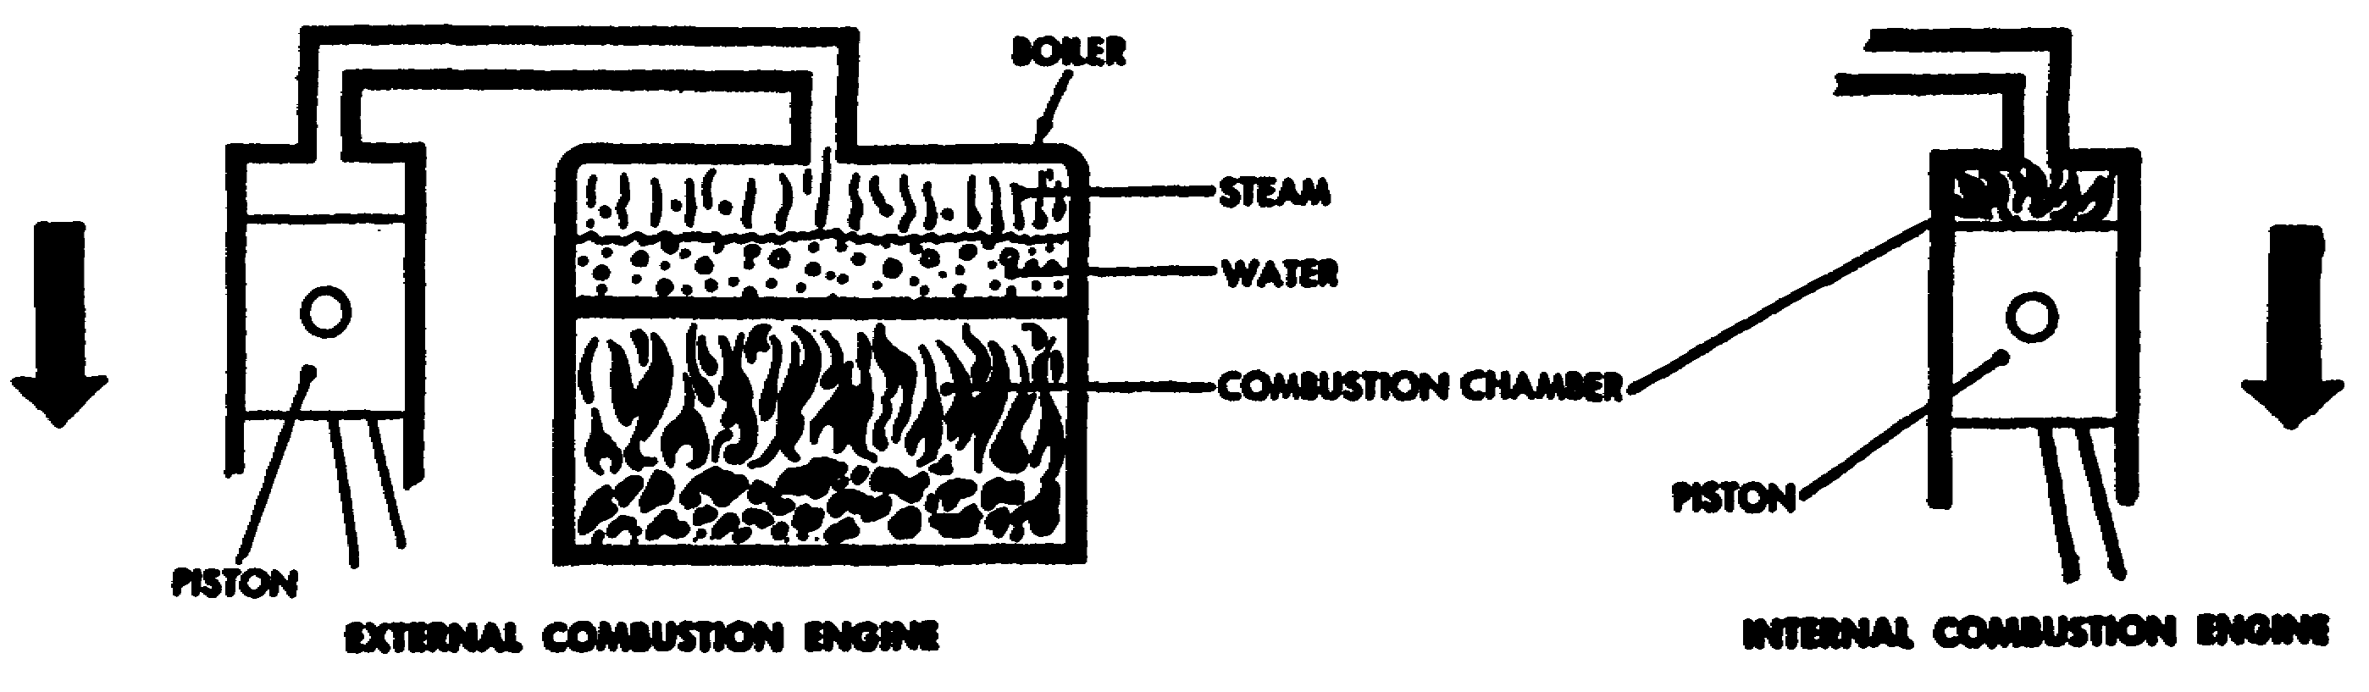

Figure 1-1. Comparison of Internal and External
Combustion Engines.

3 OD0610

b. No matter how many cylinders an engine has, whether 1, 2, 4, 6, or 12, the same actions take place in each cylinder. Much can be learned about construction and operation by studying a single cylinder engine (Figure 1-2). This engine is a four-stroke cycle, internal combustion, gasoline engine; these terms are explained in subsequent paragraphs.

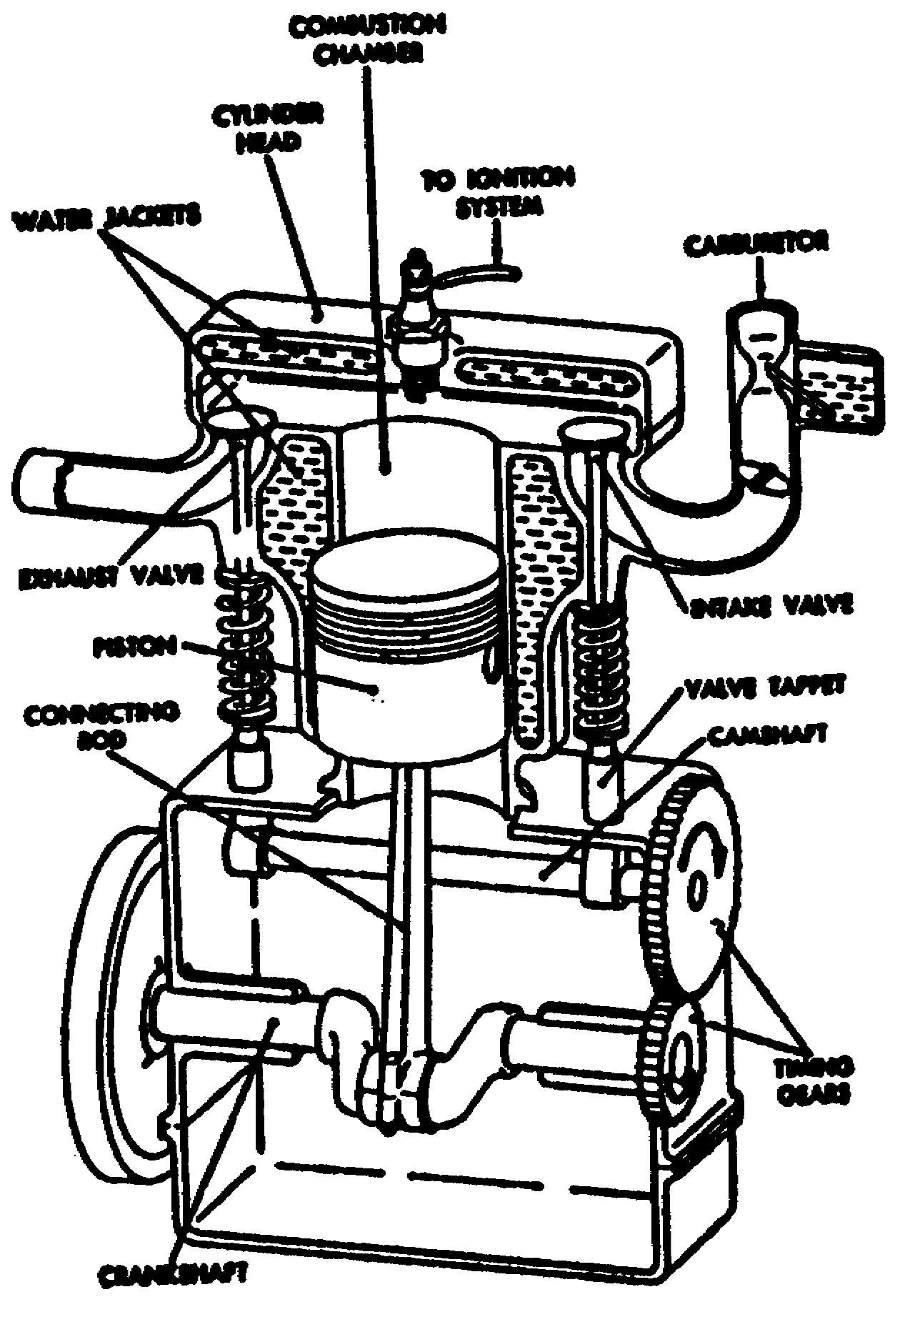

Figure 1-2. Single-Cylinder, Four-Stroke, Internal Combustion
Gasoline Engine (Cut-Away View).

(1) Cylinder and piston. Each cylinder of a typical engine has a piston that reciprocates (moves up and down or back and forth) within the cylinder and is connected to the crankshaft by a link known as a connecting rod (Figure 1-3). Engine pistons transmit the force of the explosion to the crankshaft through the connecting rod, and act as a guide for the upper end of the connecting rod, and serve as a carrier for the piston rings used to seal the piston in the cylinder. The top of the piston may be flat, concave, convex, or a great variety of shapes to promote turbulence or help control combustion.

4 OD0610

(2) Connecting Rod and Crankshaft. The up-and-down movement of the piston is called reciprocating motion. This reciprocating motion must be changed to rotary motion to propel the vehicle. The change is accomplished by the crankshaft and a connecting rod which connects the piston (Figure 1-3) and the crankshaft. The connecting rod is attached to the piston by a piston pin or "wrist pin". The pin passes through the bearing and surfaces in the piston and connecting rod. The lower end of the connecting rod is attached to the crankpin on the crankshaft. As the piston moves up and down in the cylinder, the upper end of the connecting rod moves up and down with it.

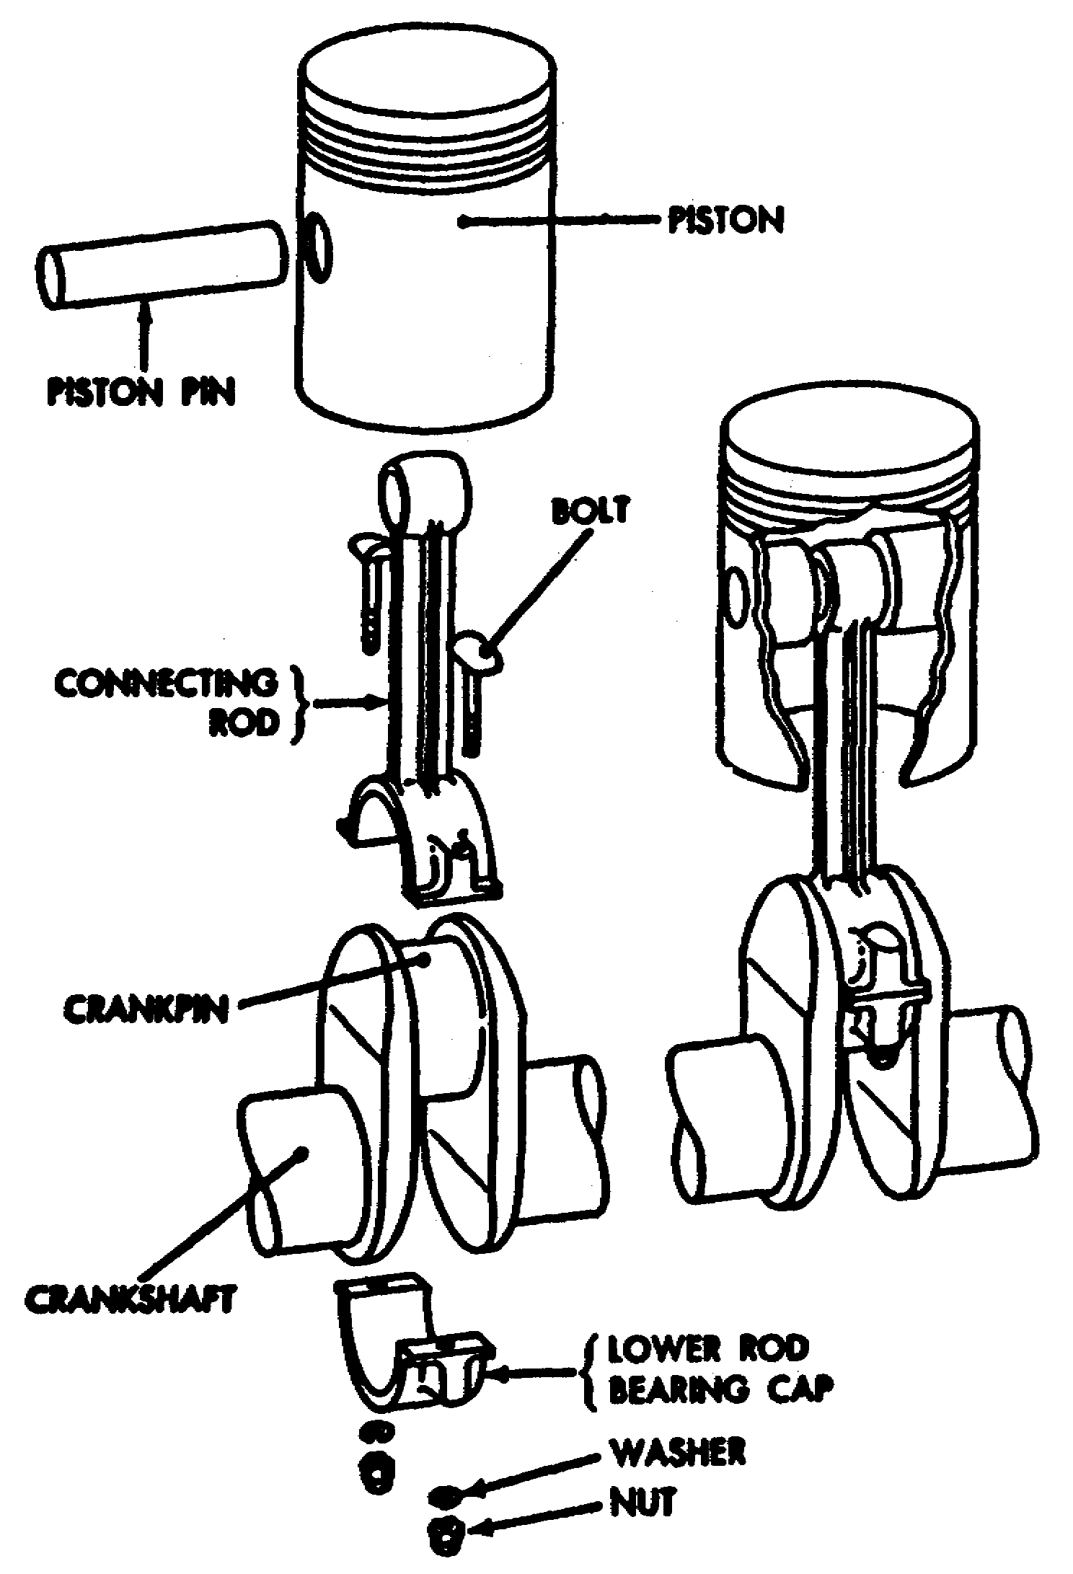

Figure 1-3. Piston, Connecting Rod, and Piston Pin.

5 OD0610

(3) Stroke. The lower end of the connecting rod also moves up and dawn but, because it is attached to the crankpin on the crankshaft (Figure 1-4), it also moves in a circle. Each movement of the piston from the top to the bottom or from bottom to top is called a stroke. The piston takes two strokes as the crankshaft makes one complete revolution, an upstroke and a downstroke. When the piston is at the top of a stroke, it is said to be at top dead center (TDC). When the piston is at the bottom of the stroke, it is said to be bottom dead center (BDC). These positions are called rock positions.

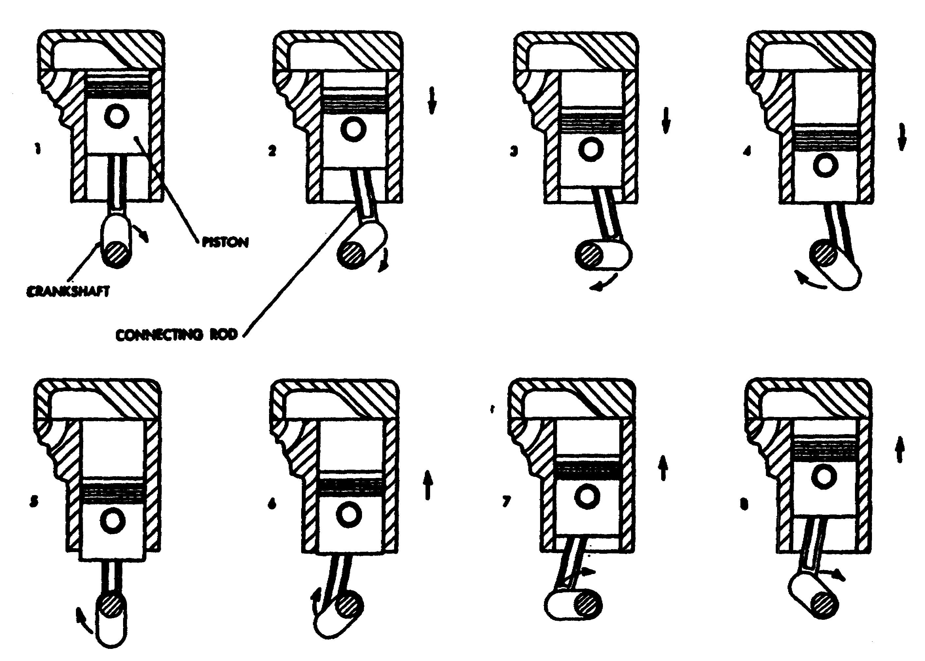

Figure 1-4. Relationship of Piston, Connecting Rod, and Crank
on Crankshaft as Crankshaft Turns One Revolution.

6 OD0610

(4) Valves. There are two valves (Figure 1-5) at the top of the cylinder. A valve is an accurately machined plug that fits into a machined opening at the top of the cylinder. When the valve is resting in this position, it is said to be seated. When a valve is so positioned, it is closed and the opening is sealed off. When the valve is pushed off its seat, it is opened. The valves in the cylinder are closed part of the time and opened part of the time. One of the valves, called the intake valve, opens to admit a mixture of fuel and air into the cylinder. The other valve, called the exhaust valve, opens to allow the escape of burned gases after the fuel and air mixture has burned. Valves are opened by the camshaft rotation and closed by a spring.

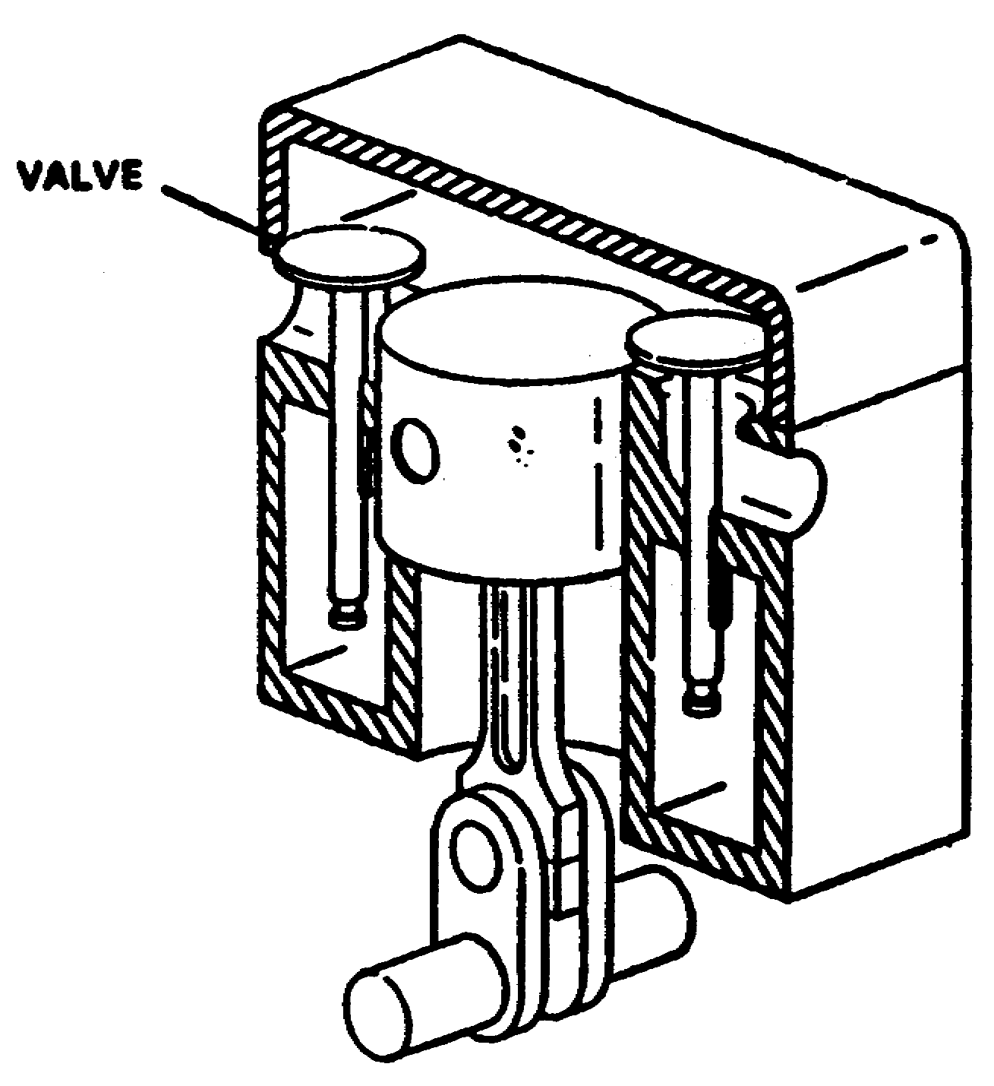

Figure 1-5. Intake and Exhaust Valves.

(5) Camshaft. The camshaft is designed to open the intake valve at the beginning of the intake stroke and hold it open long enough to obtain the most efficient filling of the cylinder. Likewise, the camshaft opens the exhaust valve at the beginning of the exhaust stroke and holds it open long enough to obtain the most efficient emptying of the cylinder. In most engines, the lobes on the camshaft are designed to open the valves smoothly and gradually. This avoids shock to the valves and allows quietness of operation.
The final design is usually a compromise between efficiency and quiet operation. When the cam lobe rotates out of the way, the valve is closed and held closed by spring pressure. In four-stroke engines, each valve is opened every other revolution of the crankshaft, so the camshaft is geared to run at one-half the crankshaft speed.

7 OD0610

2. Classification of Engines. Automotive engines may be classified according to the type of fuel used, type of cooling system employed, or valve and cylinder arrangement. They all operate on the same basic principles, and are constructed to meet the needs of the system it will be used for.

a. Fuel.

(1) Gas. A hydrocation, obtained from petroleum, that is suitable as an internal combustion engine fuel.

(2) Diesel. The substance that is burned to produce heat and create motion of the piston on the power stroke in an engine.

b. Cooling. Engines are classified as to whether they are air- or liquid-cooled. All engines are cooled by air to some extent, but air-cooled engines are those in which air is the only external cooling medium. Lubricating oil and fuel help cool engine parts, but there must be an additional external means of dissipating the absorbed heat.

(1) Air-Cooled. Air-cooled engines are used extensively in military vehicles as well as in aircraft. This type is used where there must be an economy of space and weight. It does not require a radiator, water jacket, coolant, or a pump to circulate the coolant. The cylinders are cooled by conducting the heat to metal fins on the outside of the cylinder walls and head. To effect the cooling, air is circulated between the fins. When possible, the engine is installed so it is exposed to the air stream of the vehicle; the baffles direct the air to the fins. If the engine cannot be mounted in the air stream, a fan is used to force the air through the fins.

(2) Liquid-Cooled. Water-cooled engines require a water jacket to hold the coolant around the valve ports, combustion chambers, and cylinders; a radiator dissipates the heat from the coolant to the surrounding air; and a pump circulates the coolant through the engine. Water-cooled engines also require a fan to pass air through the radiator because the speed of the vehicle does not always force enough air through the radiator to provide proper dissipation of heat.

c. Valve arrangement. Engines may be classified according to the position of the intake and exhaust valves; that is, whether they are in the cylinder block or in the cylinder head. Various arrangements have been used, but the most common are L-head, I-head, and F-head. The letter designation is used because the shape of the combustion chamber resembles the form of the letter identifying it.

8 OD0610

(1) L-Head. In L-head engines, both the valves are placed in the block on the same side of the cylinder. The valve-operating mechanism is located directly below the valves, and one camshaft actuates both the intake and exhaust valves. This type has taken place of the T-head, in which both valves are in the block but on opposite sides of the cylinder. The disadvantage of the T-head was that it required two complete valve-operating mechanisms.

(2) I-Head. Engines using the I-head construction are commonly called valve-in-head or overhead valve engines. This arrangement requires a tappet, push rod, and a rocker arm above the cylinder to reverse the direction of the valve movement, but only one camshaft is required for both valves. Some overhead valve engines make use of an overhead camshaft. This arrangement eliminates the long linkage between the camshaft and valve.

(3) F-Head. In F-head engines, the intake valves normally are located in the head, while the exhaust valves are located in the engine block. This arrangement combines, in effect, the L-head and the I-head valve arrangements. The valves in the head are actuated from the camshaft through tappets, push rods, and rocker arms (I-head arrangement), while the valves in the block are actuated directly from the camshaft by tappets (L-head arrangements).

d. Cylinder Arrangement. Automotive engines also vary in the arrangement of cylinders, depending on the engine use. Cylinder arrangement in liquid-cooled engines is usually in-line or V-type; in air-cooled engines, it is V-type, radial, or horizontal-opposed.

(1) In-Line. The vertical in-line cylinder arrangement is one of the most widely used. All cylinders are cast or assembled in a straight line above a common crankshaft which is immediately below the cylinders. A variation is the inverted in-line type.

(2) V-Type. In the V-type engine, two in-line cylinders are mounted in a "V" shape above a common crankshaft.

(3) Radial Engines. The radial engine has cylinders placed in a circle around the crankshaft.

(4) Horizontal-Opposed. The horizontal-opposed engine has cylinders laid on their sides in two rows, with the crankshaft in the center.

9 OD0610

(5) Horizontal-Opposed with Vertical Crankshaft. In this engine, the cylinders are horizontal and opposed to each other, but the crankshafts set vertically.

3. Engine Operation. In any internal combustion engine, there is a definite sequence of events that must occur. The actions that take place within the engine cylinder may be divided into four basic parts, called strokes (Figure
1-6).

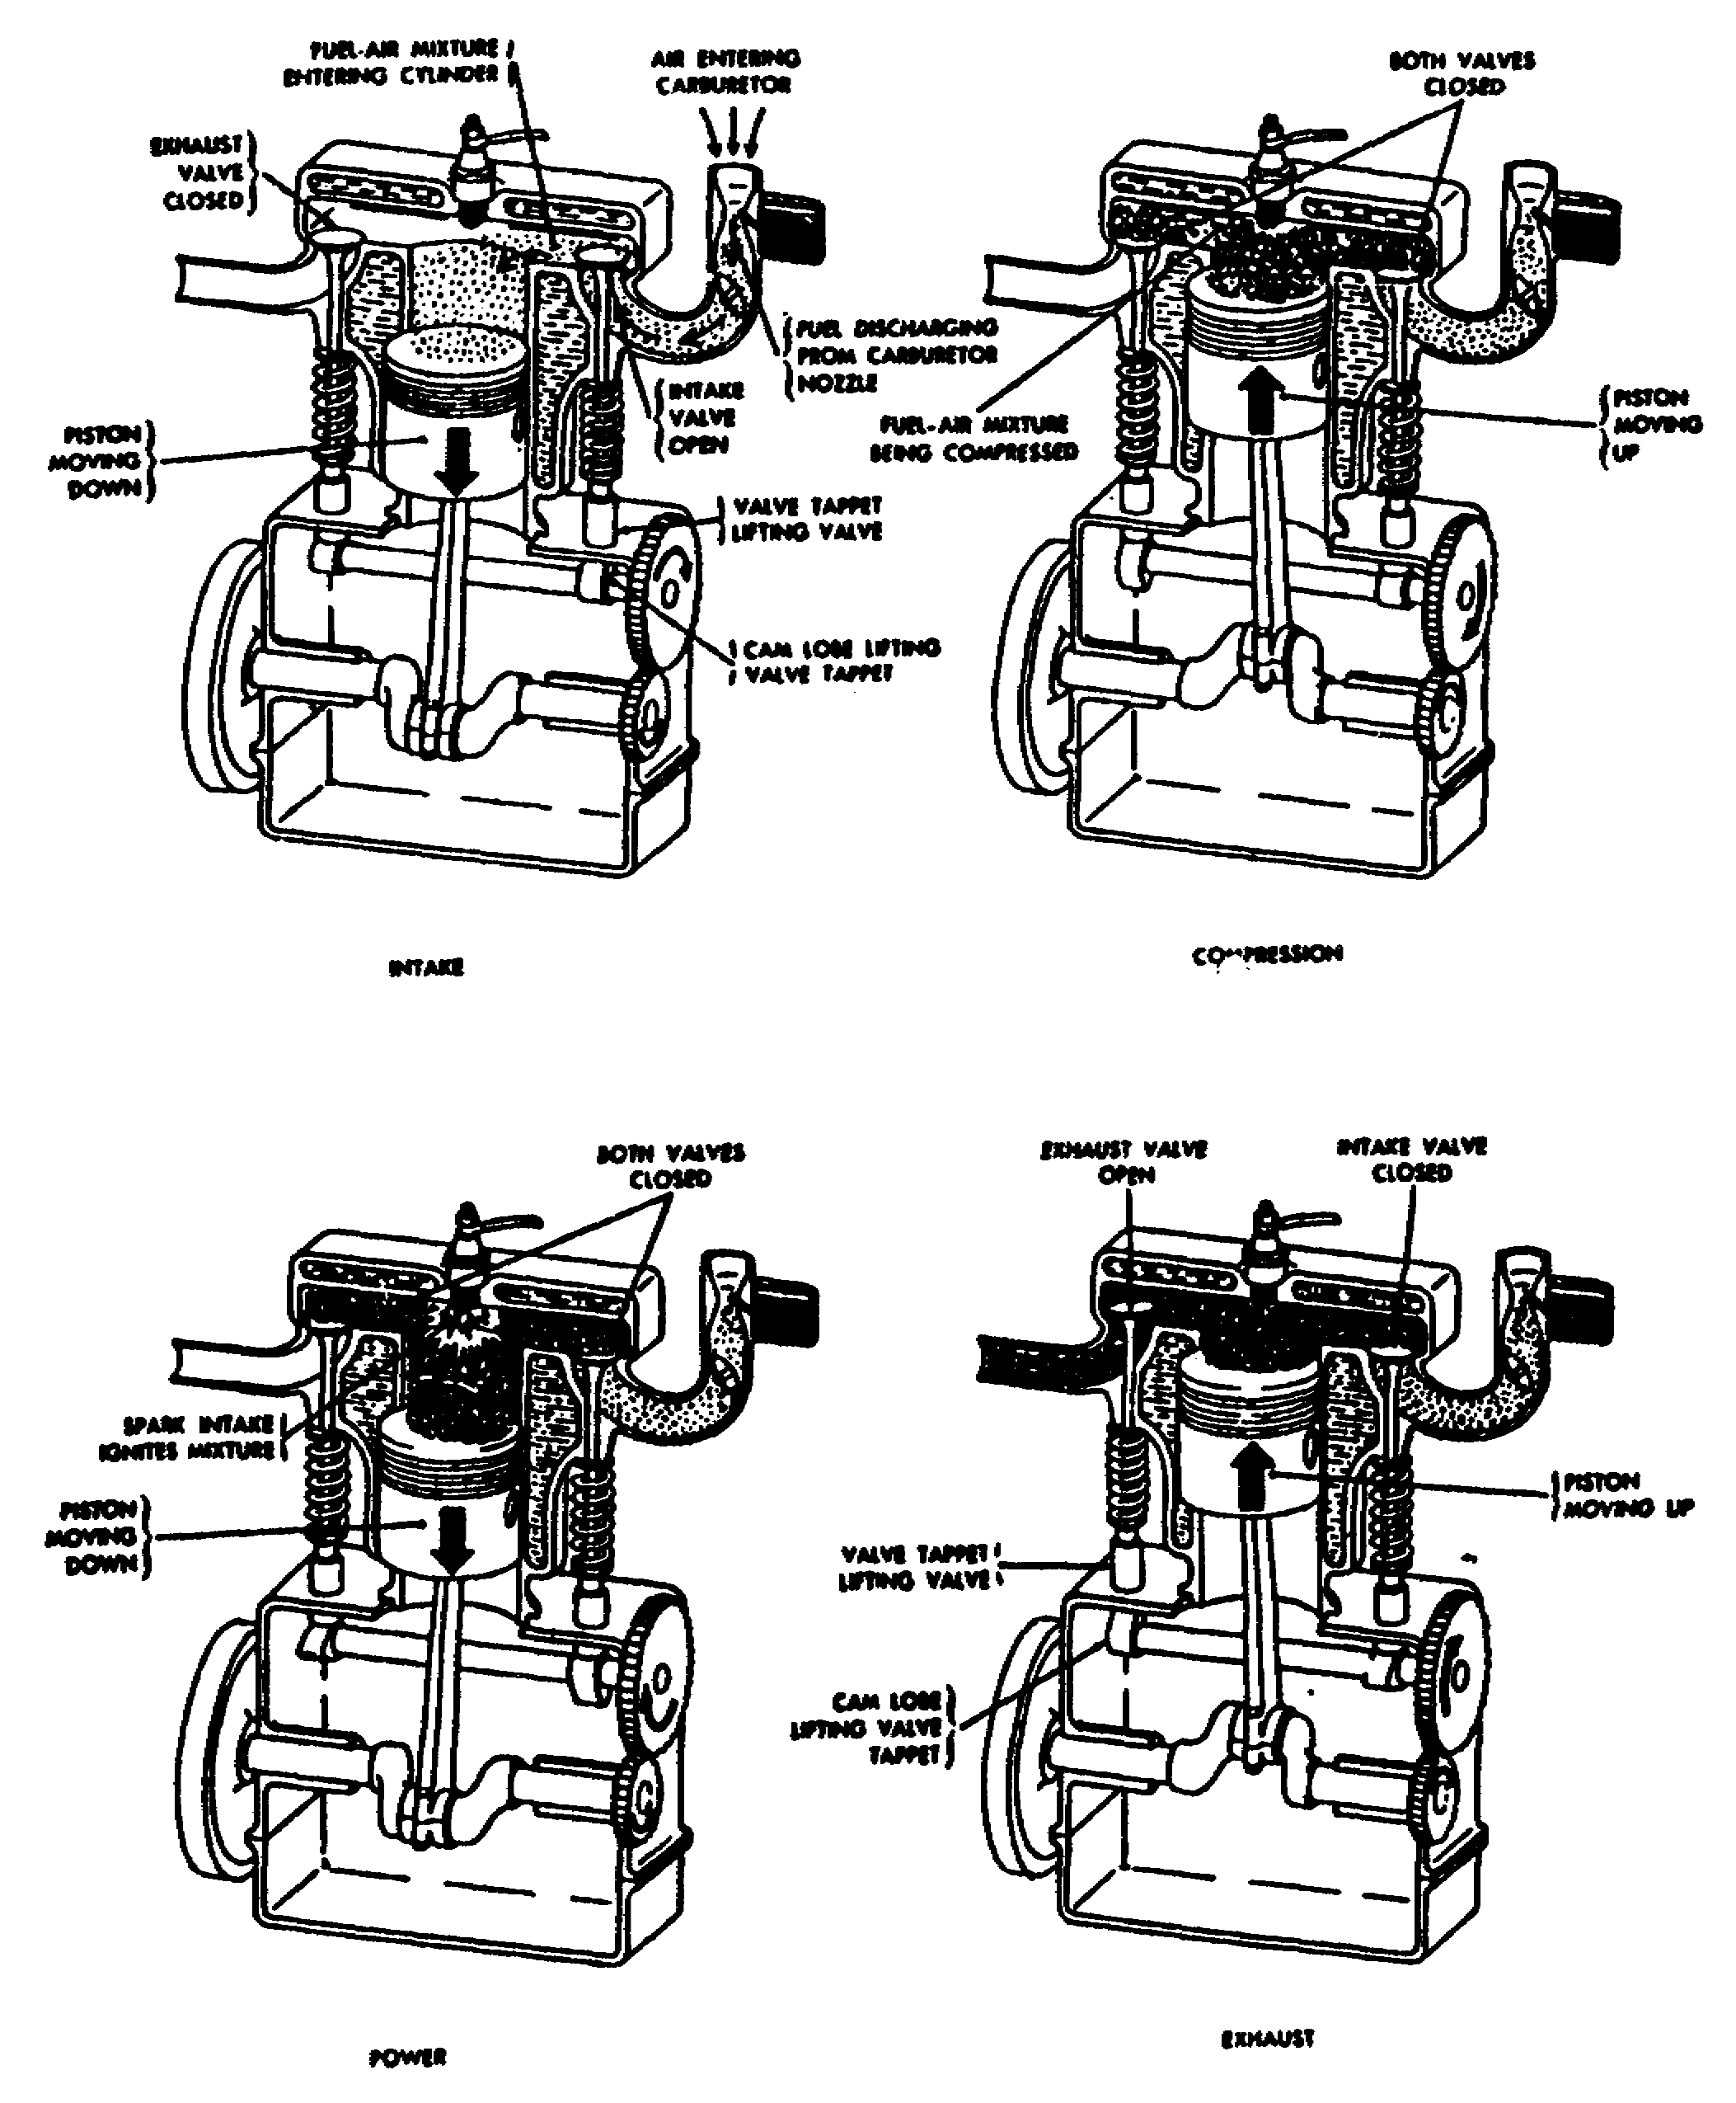

Figure 1-6. The Four Strokes in the Four-Stroke
Cycle, Gasoline Engine.

10 OD0610

a. Intake stroke. The piston moves downward and the intake valve opens. This downward movement of the piston produces a partial void, or vacuum, in the cylinder, and air rushes into the cylinder past the opened intake valve. This has somewhat the same effect as drinking through a straw: partial vacuum is produced in the mouth and the liquid moves up through the straw to fill the vacuum (Figure 1-7). In the engine, the inrushing air passes through the carburetor before it enters the cylinder. The carburetor charges the air with gasoline vapor to produce a combustible mixture.

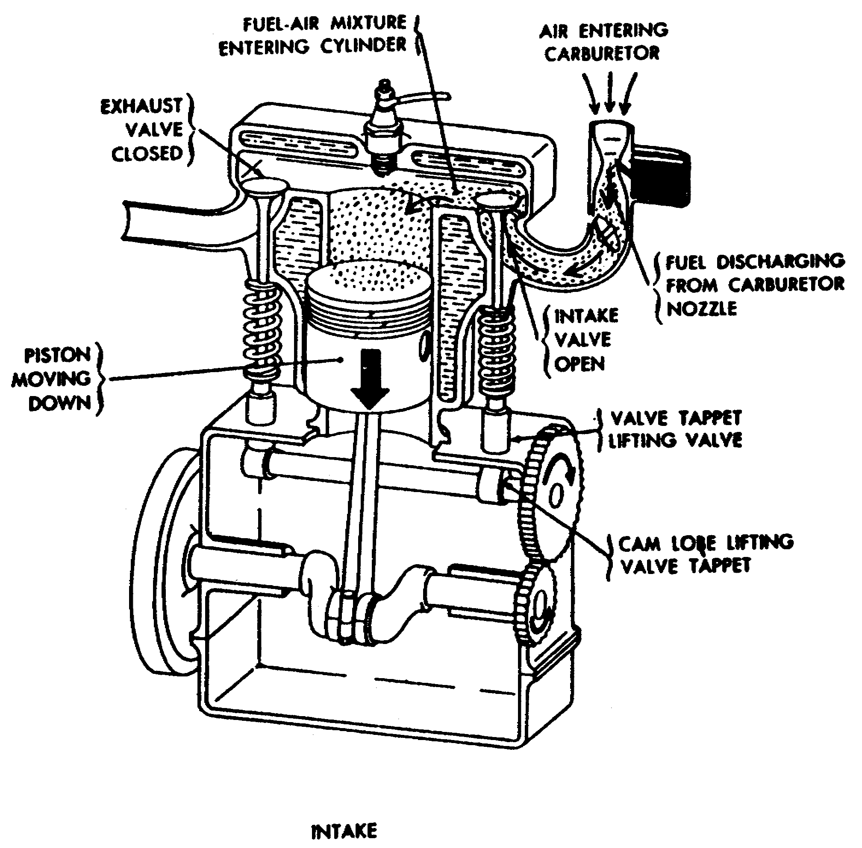

Figure 1-7. Intake Stroke.

11 OD0610

b. Compression stroke. The piston reaches the bottom of the intake stroke and the intake valve closes. Both intake and exhaust valves are now closed, sealing the upper end of the cylinder. The rising piston compresses the air-fuel mixture. The mixture is compressed to one-sixth or one-seventh of its original volume. This is the same as one gallon of air compressing until a little more than a pint of air is left. Compressing the mixture makes it more combustible; the energy in the fuel is concentrated into a smaller space. The mixture of air and fuel is ignited near or at the top of the compression stroke (Figure 1-8).

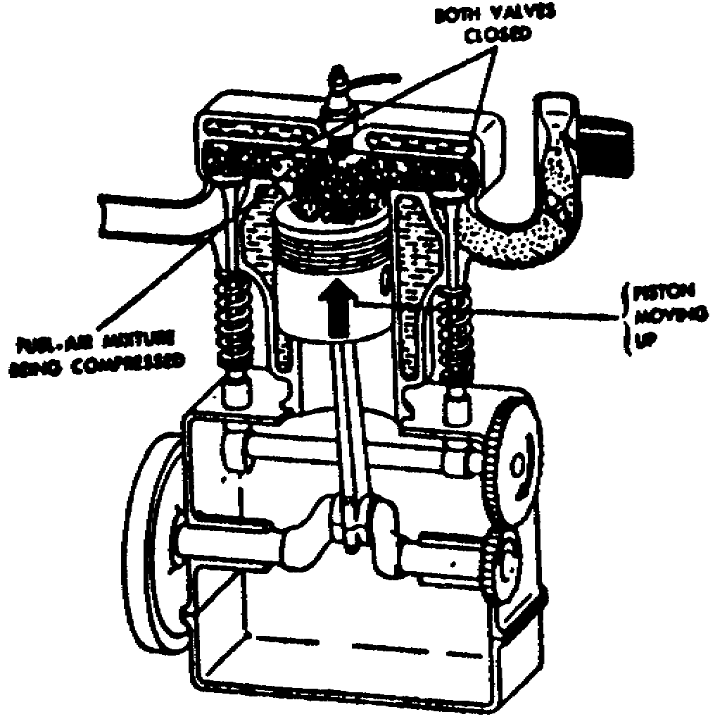

Figure 1-8. Compression Stroke.

c. Power stroke. At the upper limit of piston movement (near top dead center), the compressed air-fuel mixture is ignited. The ignition system produces a spark in the cylinder causing the mixture to burn. The generated pressure forces the piston downward on the power stroke (Figure 1-9).

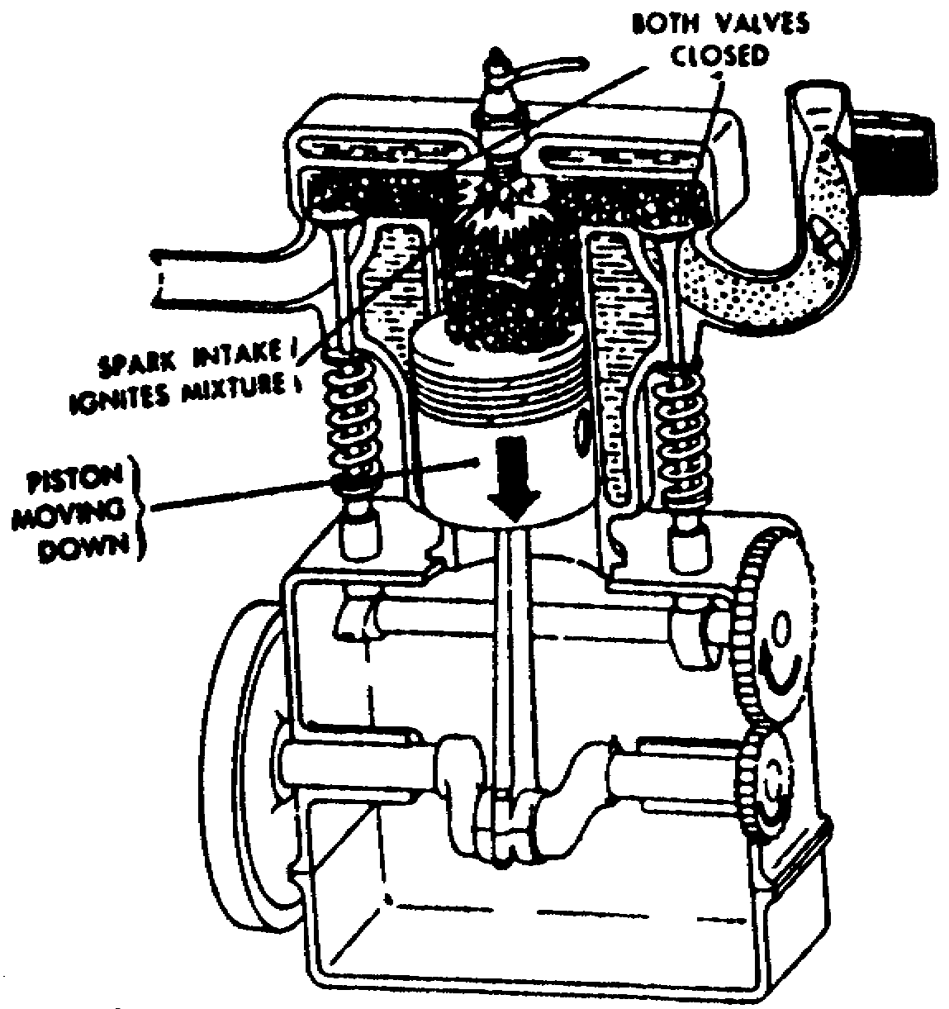

Figure 1-9. Power Stroke.

12 OD0610

d. Exhaust stroke. After the air-fuel mixture has turned, it must be cleared from the cylinder. This is done by opening the exhaust valve just as the power stroke is finished and the piston starts back up on the exhaust stroke. The piston forces the burned gases out of the cylinder, past the opened exhaust valve. The four strokes (intake, compression, power, and exhaust) must be automatically repeated over and over in the same sequence in each cylinder if the engine is to run (Figure 1-10).

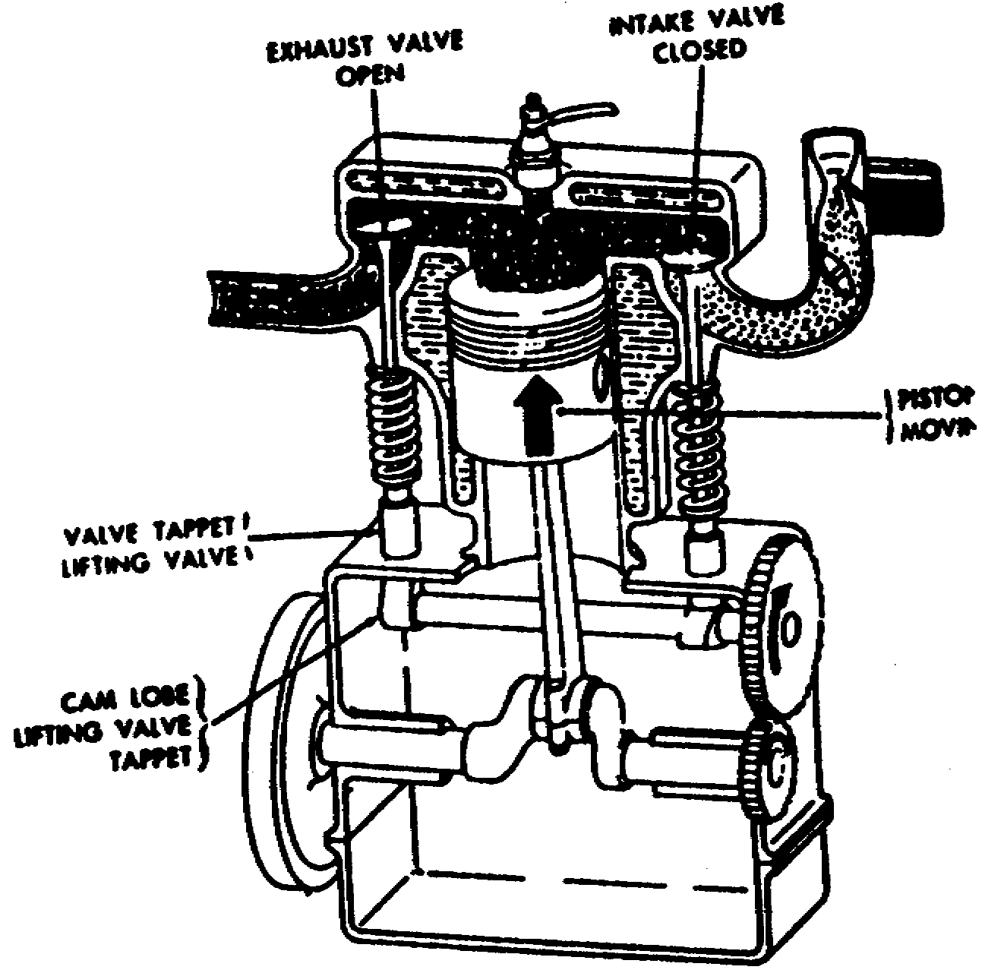

Figure 1-10. Exhaust Stroke.

4. Four-Stroke and Two-stroke Engines. The engines described in paragraphs 2 and 3 and illustrated in Figures 1-6 through 1-10 are a four-stroke cycle engine. Four strokes of the piston, with two revolutions of the crankshaft and one revolution of the camshaft are required for the complete cycle of events.
This type of engine is also called a four-stroke Otto-cycle engine because it was Dr. N.A. Otto who, in 1976, first applied the principles of this engine.
In the two-stroke cycle engine, the entire cycle of events (intake, compressions, power, and exhaust) takes place in two piston strokes.

13 OD0610

a. Two-Stroke cycle. A two-stroke cycle gasoline engine is shown in Figure 1-11. Every other stroke on this engine is a power stroke. Each time the piston moves down, it is on the power stroke. Intake, compression, power, and exhaust still take place, but they are completed in just two strokes. Intake and exhaust ports are cut into the cylinder wall instead of being placed at the top of the combustion chamber as in the four-stroke cycle engine. As the piston moves down on its power stroke, it first uncovers the exhaust port to let burned gases escape and then it uncovers the intake port to allow a new air-fuel mixture to enter the combustion chamber. Then on the upward stroke, the piston covers both ports and at the same time, compresses the new mixture in preparation for ignition and another power stroke. In the engine shown in Figure 1-11, the piston is shaped so that the incoming air-fuel mixture is directed upward, sweeping out ahead of it the burned exhaust gases. Also, there is an inlet into the crankcase through which the air-fuel mixture passes before it enters the cylinder. This inlet is opened as the piston moves upward, but it is sealed off as the piston moves downward on the power stroke. The downward moving piston slightly compresses the mixture in the crankcase, giving the mixture sufficient pressure to pass rapidly through the intake port as the piston clears this port. This improves the "sweeping-out", or scavenging effect of the mixture as it enters and clears the burned gases from the cylinder through the exhaust port.

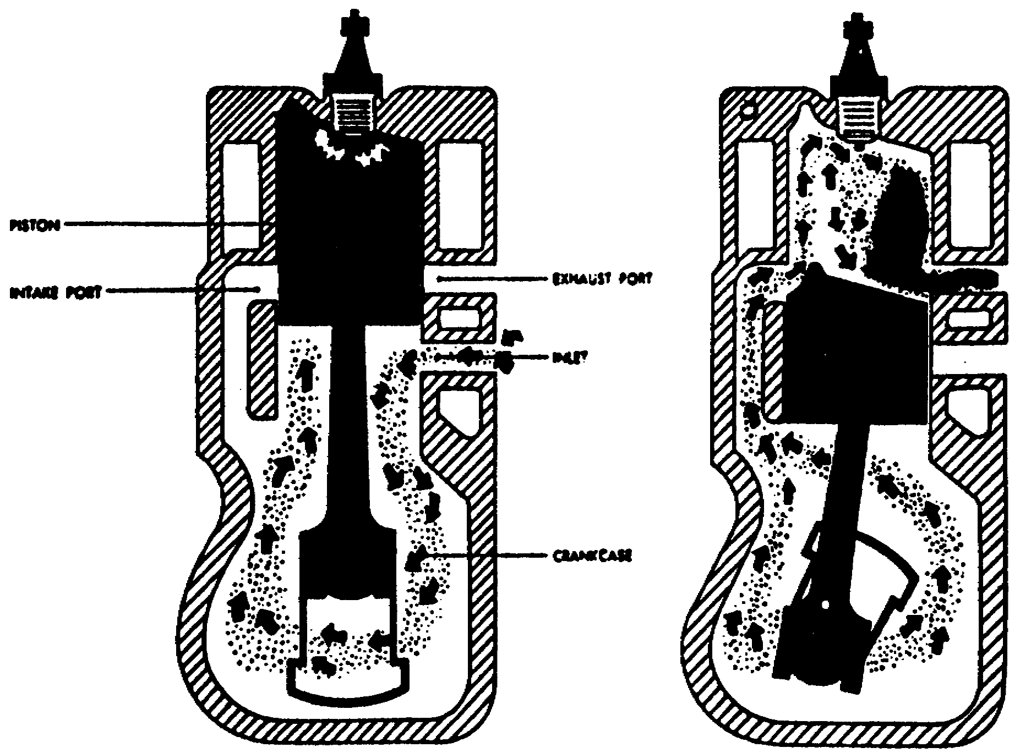

Figure 1-11. Events in A Two-Stroke Cycle,
Internal Combustion Engine.

14 OD0610

b. Comparison of Two-Stroke Cycle Engines. It might appear that a two-stroke cycle engine could produce twice as much horsepower as a four-stroke cycle engine of the same size, operating at the same speed. This is not the case. To scavenge the burned gases at the end of the power stroke and during the time both the intake and exhaust ports are open, the fresh air-fuel mixture rushes into and through a cylinder, a portion of the fresh air-fuel mixture mingles with the burned gases and is carried out the exhaust port. Also, due to the much shorter period, the intake port is open (as compared to the period the intake valve in a four-stroke cycle engine is open), a relatively smaller amount of air-fuel mixture is admitted. With less air-fuel mixture, less power per power stroke is produced as compared to the power produced in a four-stroke cycle engine of like size operating at the same speed, and with other conditions being the same. To increase the amount of air-fuel mixture, auxiliary devices are used with two-stroke cycle engines to assure delivery of greater amounts of air-fuel mixture into the cylinder. Figure 1-11 shows one device that uses compression in the crankcase. Other engines may use superchargers or turbochargers or both to increase power. Obviously, the greater the pressure developed, the more air carried into the cylinder.

15 OD0610

LESSON, PART A

Practice Exercise

The following items will test your grasp of the materials covered in this lesson. There is only one correct answer for each item. When you have completed the exercise, check your answers with the answer key that follows. If you answer any item incorrectly, study again that part of the lesson which contains the portion involved.

1. What is the up-and-down movement of the piston called?

2. What is each movement of the piston from the top to bottom or from bottom to top called?

3. What operates both intake and exhaust valves?

4. What is every dawn stroke on a two-stroke engine called?

17 OD0610

PRACTICE EXERCISE

ANSWER KEY AND FEEDBACK

Item Correct Answer and Feedback

1. Reciprocating motion is the up-and-down movement piston in the cylinder. Page 5, para (2).

2. Each movement of the piston from top to bottom or from bottom to top is called a stroke. Page 6, para (3).

3. Camshaft operates both intake and exhaust valves. Page 7, para (5).

4. Every down stroke in a two-stroke cycle engine is a power stroke. Page 14, para a.

18 OD0610

LESSON CONTENT

Part B.

Diesel Engines. Upon completion of Part B, you will be able to explain the principles of operation of two-stroke and four-stroke cycle diesel engines. The diesel engine bears the name of Dr. Rudolph Diesel, a German engineer. He is credited with constructing, in 1897, the first successful diesel engine using liquid fuel. His objective was an engine with greater fuel economy than the steam engine, which used only a small percentage of energy contained in the coal burned under its boiler. Dr. Diesel originally planned to use pulverized coal as fuel, but his first experimental engine in 1893 was a failure. After a second engine failed, he changed his plan and used liquid fuel.

a. Characteristics of Diesel Engines. Diesel engines are similar to gasoline engines and are built in both two- and four-stroke designs. They may be water or air cooled. In general, they are heavier in structure to withstand the higher pressures resulting from the increased compression ratios used. In some diesel engines, the compression ratio may be as high as 18 to 1.

(1) Fuel Intake and Ignition of Air-Fuel Mixture. The main difference between gasoline and diesel engines (Figure 1-12) is in the method of introducing fuel into the cylinders and igniting the air-fuel mixture. Fuel and air are mixed together before they enter the cylinder of the gasoline engine. The mixture is compressed by the upstroke of the piston and is ignited within the cylinder by a spark plug. Air alone enters the cylinder of a diesel engine. The air is compressed by the upstroke of the piston and the diesel fuel is injected into the combustion chamber near the top of the upstroke (compression stroke). The air becomes hot enough (1000 to 2000 F) to ignite the fuel as it is sprayed into the combustion chamber by the injector (compression ignition). No spark plug is used in the diesel engine; ignition is by contact of the fuel with the heated air.

19 OD0610

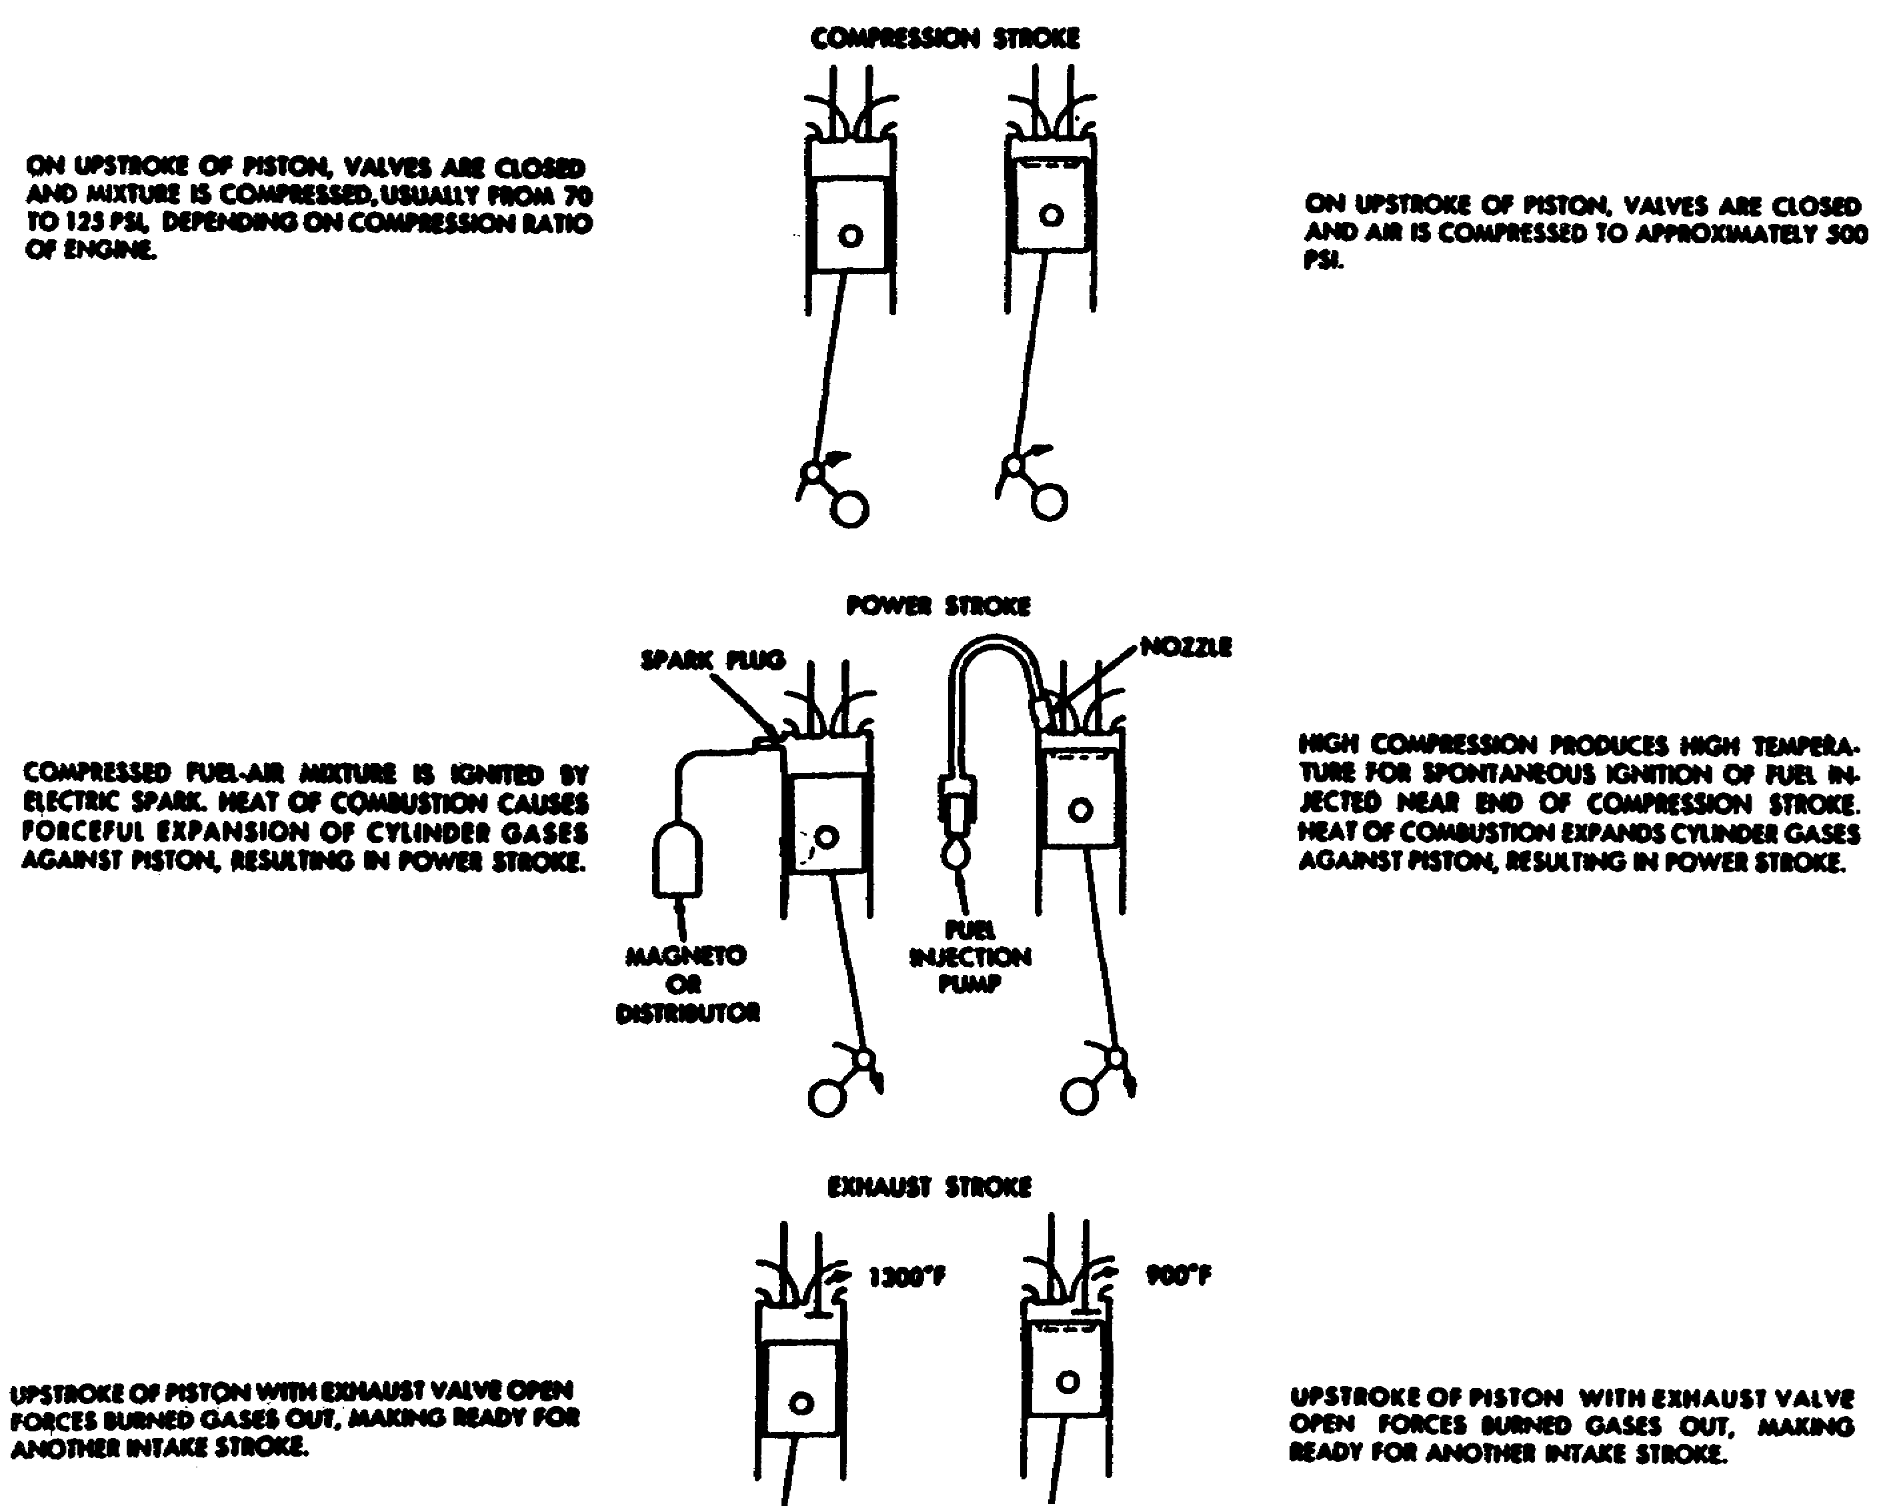

Figure 1-12. Comparison of Sequence Events in Four-Stroke
Gasoline and Diesel Engines.

20 OD0610

(2) Two-Stroke cycle diesel engines. In two-cycle diesel engines, it is necessary to force air into the cylinders and force exhaust gases at. One way to do this is to use a supercharger or "blower". The General Motors (GM) two-cycle diesel uses a positive displacement type blower to force air into the cylinders (Figure 1-13).

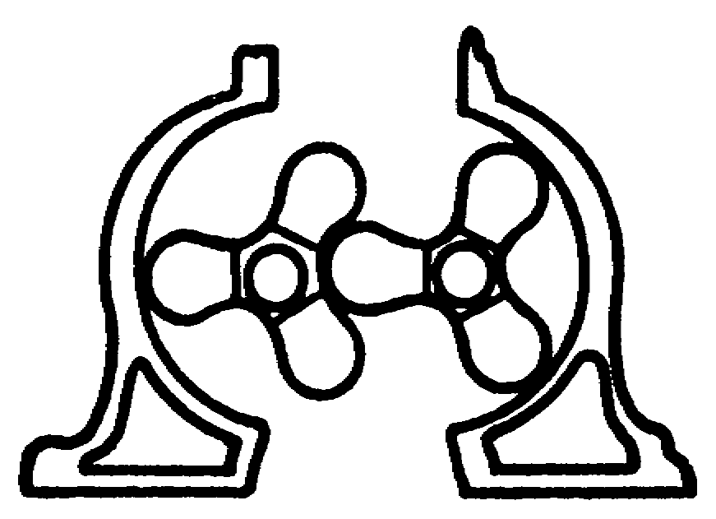

Figure 1-13. Blower.

(a) Two-cycle diesel engines do not have intake valves. One configuration used by the military has fair exhaust valves for each cylinder. Air enters the cylinder through ports in the cylinder liner instead of through intake valves (Figure 1-14). These ports are exposed each time the piston moves down. Intake and exhaust will occur in the cylinder at the same time.

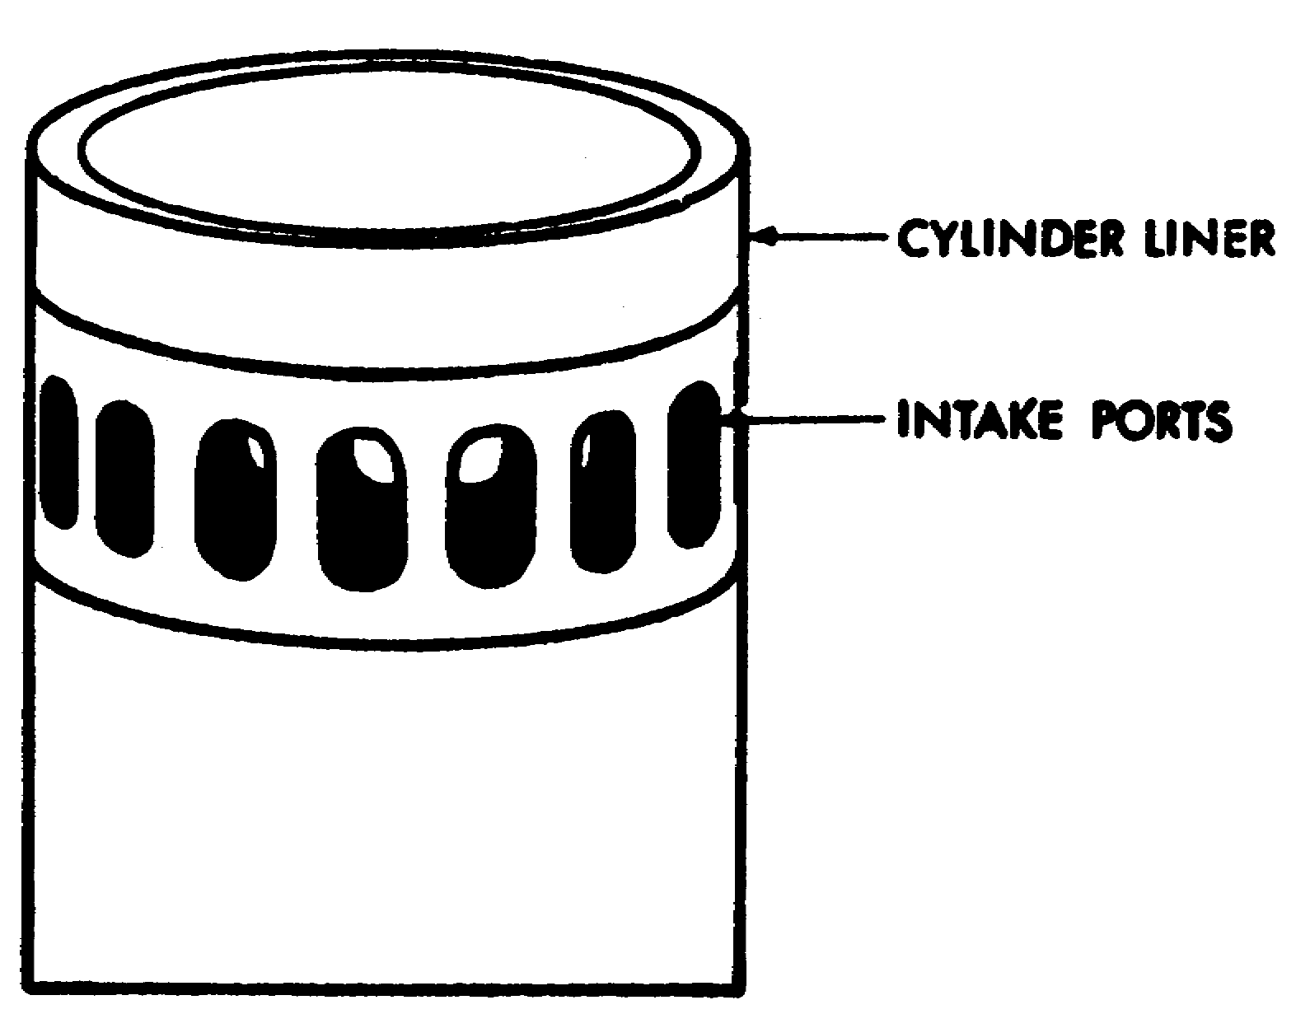

Figure 1-14. Cylinder Liner and Intake Ports.

21 OD0610

(b) When the piston is near the bottom of its stroke, the ports in the cylinder liner are exposed. Air, under pressure from the blower, is forced into the cylinder (intake). At the same time, the exhaust valves open. The incoming air helps force the exhaust gases out of the engine (exhaust). The exhaust valves close as the piston starts it compression stroke. Air is continuously forced into the cylinder until the piston blocks the ports. The air is compressed and ignited and the piston is forced back down. Every down stroke is obviously a power stroke. When the piston moves down far enough to expose the cylinder ports, the sequence begins again.

(3) Control of speed and power. The speed and the power of the diesel engines are controlled by the quantity of fuel injected into the cylinders. This is opposed to the common gasoline engine, which controls speed and power by limiting the amount of air admitted to the carburetor. In the diesel engine, a varying amount of fuel is mixed with a constant amount of compressed air inside the cylinder. A full charge of air enters the cylinder on each intake stroke. Because the quantity of air is constant, the amount of fuel injected determines speed and power output. As long as the amount of fuel injected is below the maximum established by the manufacturer who designed the engine, there is always enough air in the cylinder for complete combustion.

(4) Combustion process. In the diesel engine, there is continuous combustion during the entire length of the power stroke, and pressure resulting from combustion remains relatively constant throughout the stroke. In the gasoline engine, combustion is completed while the piston is at the upper part of travel. This means that the volume of the mixture stays about the same during most of the combustion process. When the piston does move down and the volume increases, there is a little additional combustion to maintain pressure. Because of these facts, the cycle of the gasoline engine is often referred to as having Constant Volume Combustion while the diesel cycle is said to have Constant Pressure Combustion.

b. Turbine Engine. (Figure 1-15). The turbine engine burns low performance diesel fuel mixed with compressed and heated air. Air enters the engine and flows through two compressors. The compressed air is heated by exhaust gases to aid burning. The heated and compressed air is directed into the combustion chamber where it mixes with fuel vapor. Continuous burning occurs once it has been started by an ignition spark. Gases are routed through the recuperator to heat incoming air and then exhausted.

22 OD0610

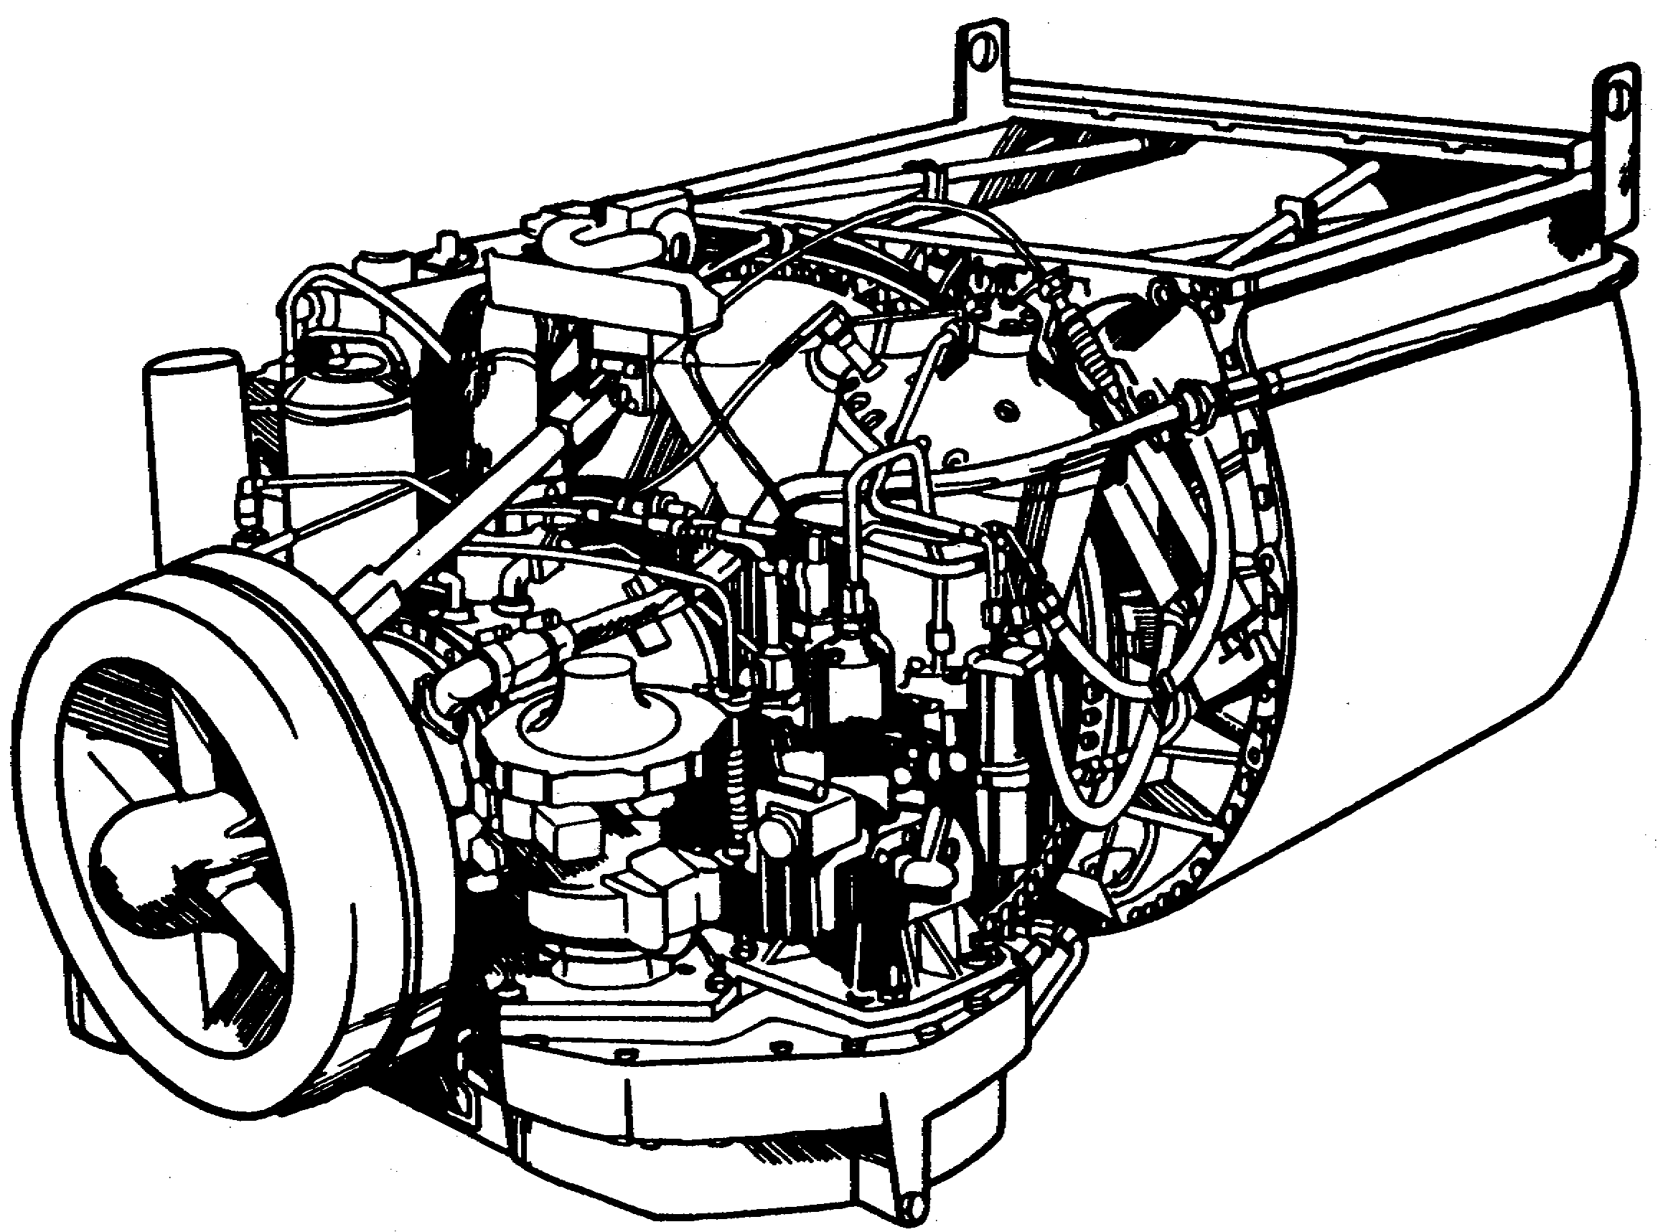

Figure 1-15. Turbine Engine.

23 OD0610

(1) Turbine engine systems. The turbine engine system consists of air and fuel control components, combustion chamber, turbines, and an exhaust system (Figure 1-16).

(a) Air Supply. The air supply for compression is drawn from outside the engine by the action of two compressors. It is cleaned and directed to the engine air inlet. From the inlet, the air flows through a low-pressure compressor section and then through a high-pressure section. The compressed air then passes into a recuperator and flows into the combustion chamber where it mixes with fuel vapor and burns.

(b) Fuel. Fuel is supplied by two control units which automatically supply the correct amount for varying engine operating conditions.

(c) Combustion. Electric ignition in the combustion chamber is used only during the starting cycle. After the start, a continuous flow of air and fuel vapor maintains a continuous burning in the combustion chamber until the fuel or the air is shut off.

(d) Turbines. Exhaust gas leaves the combustion chamber through discharge nozzles and forces a two-stage turbine to turn. The high-pressure turbine drives the high-pressure compressor rotor. The low-pressure turbines drive the low-pressure compressor rotor. After leaving the low-pressure turbine, the exhaust gas drives a two-stage power turbine. The power turbine supplies the force to turn the engine power output drive shaft.

(e) Exhaust. The exhaust gas leaving the power turbine is routed through the recuperator to heat compressed air.

24 OD0610

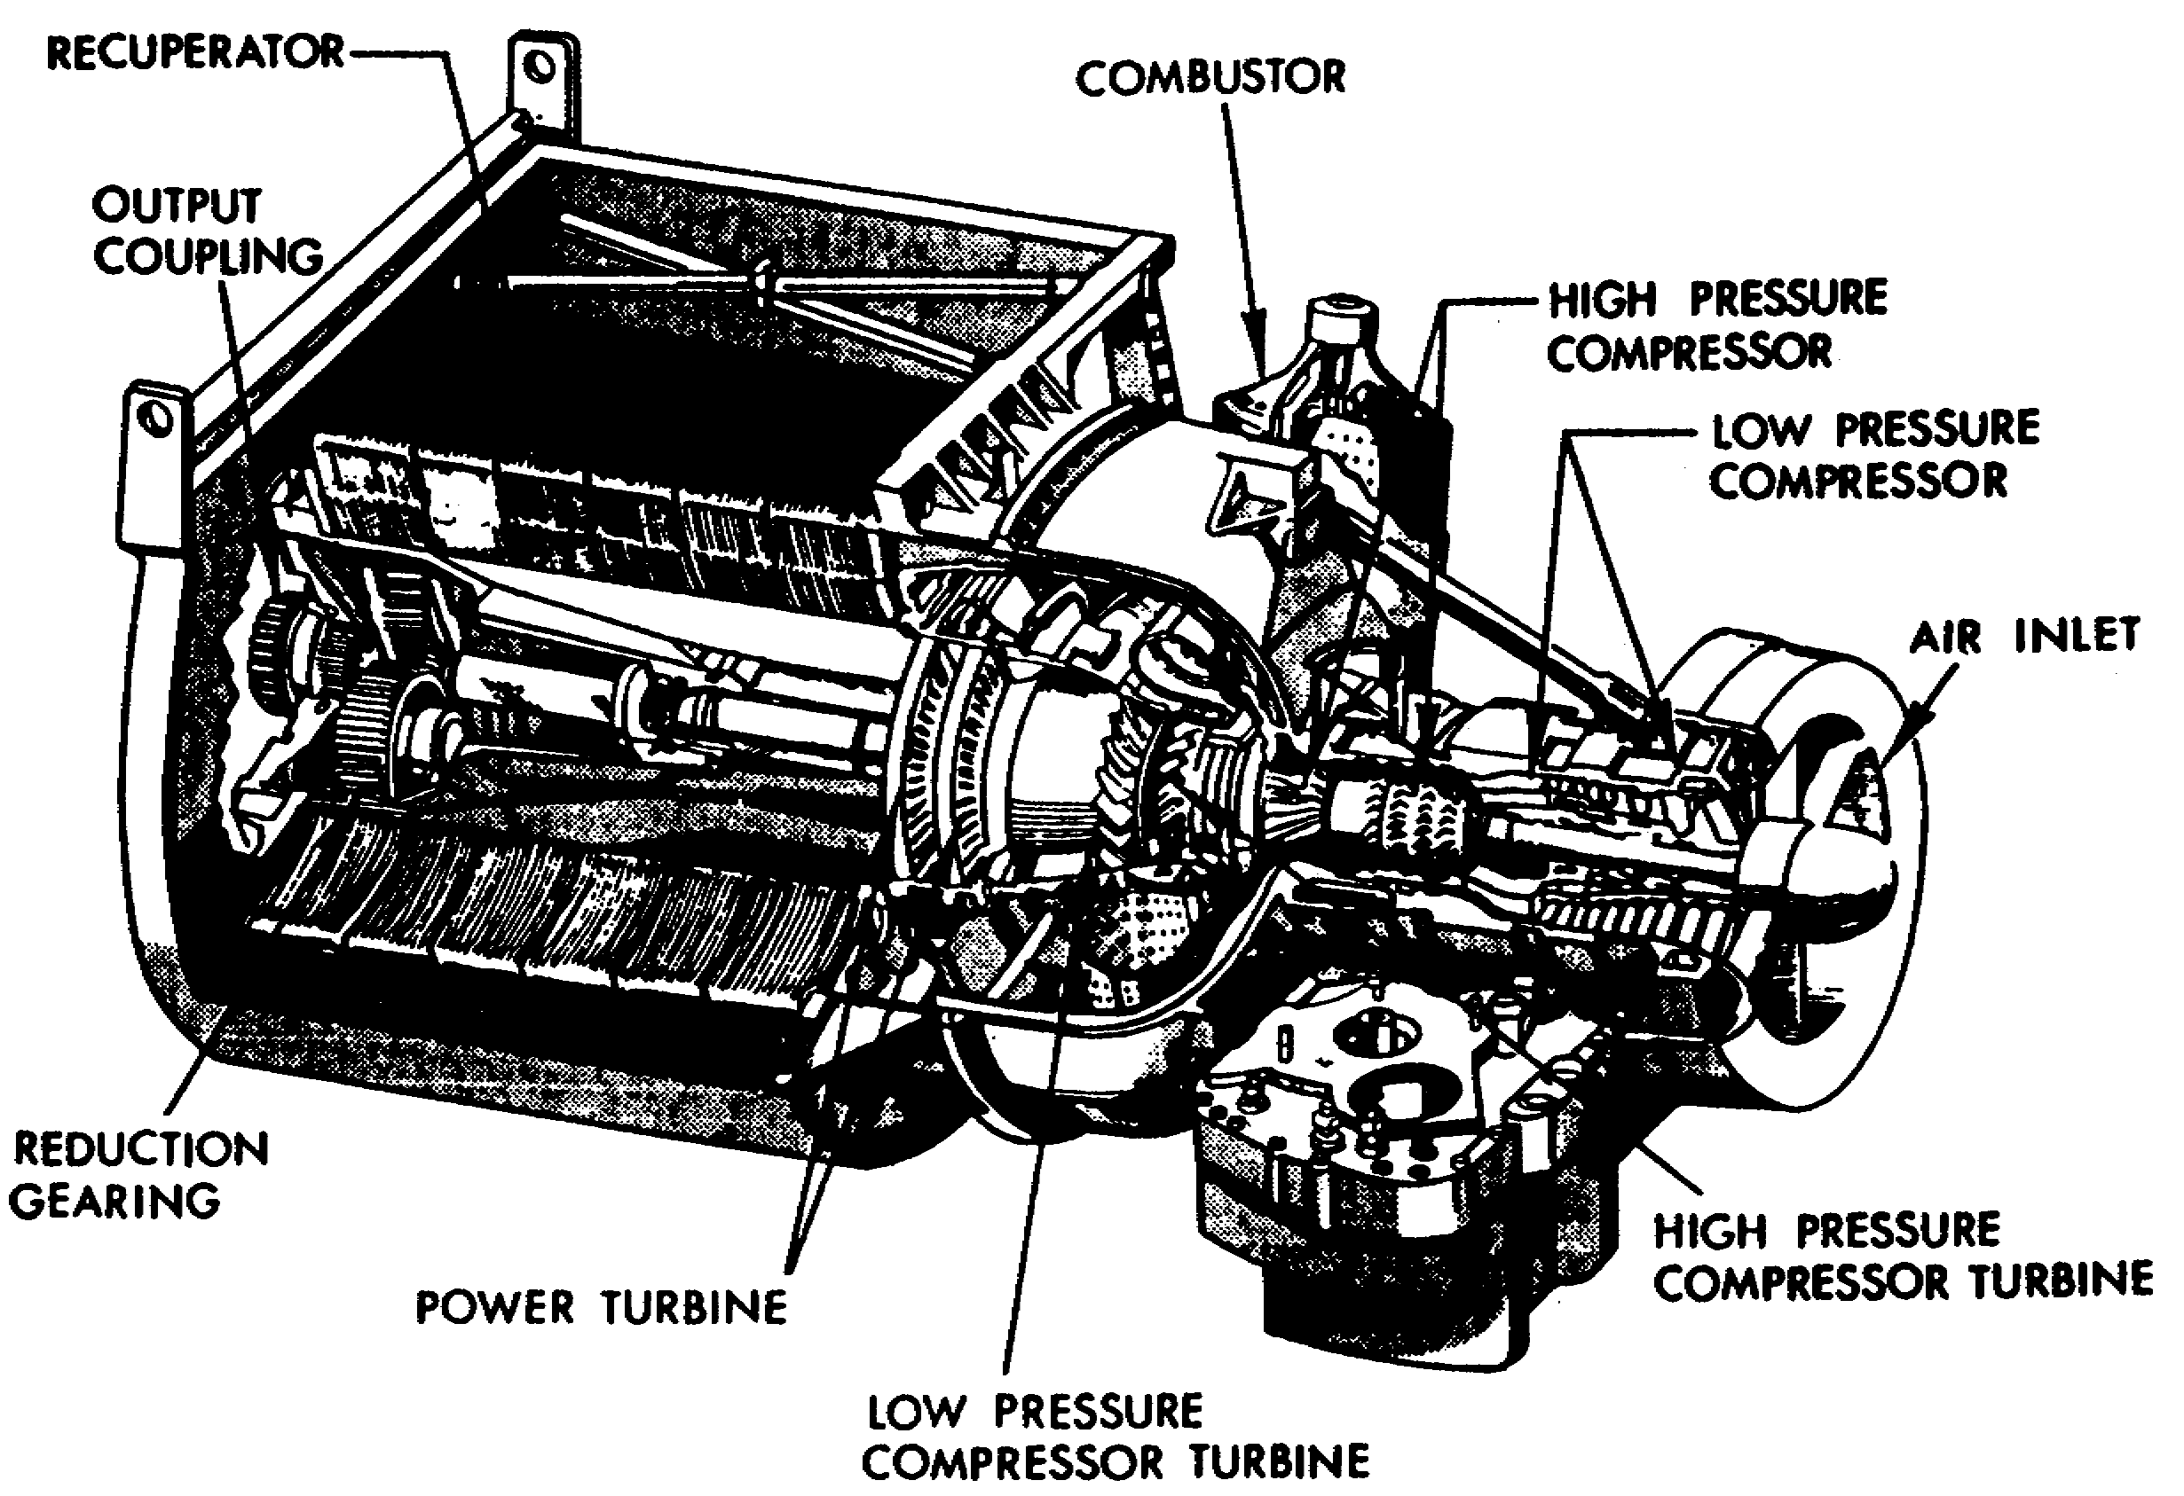

Figure 1-16. Diesel Turbine Engine Components
Construction and Operation.

(2) Turbine operation. In order to master the theory of operation behind the gas turbine engine, four basic principles must be understood: mass, pressure, accelerated mass, and conversion of energy. The following is a discussion on each.

25 OD0610

(a) Mass. All turboshaft engines attain their high rotational torque output, or power, from energy transferred to the turbines by the accelerated airmass within the engine. Figure 1-17 illustrates this concept. Within container 1, there is a certain amount of air molecules; the exact amount is referred to as mass. This airmass is one of the key components required to drive the turbine in the mass acceleration principle.

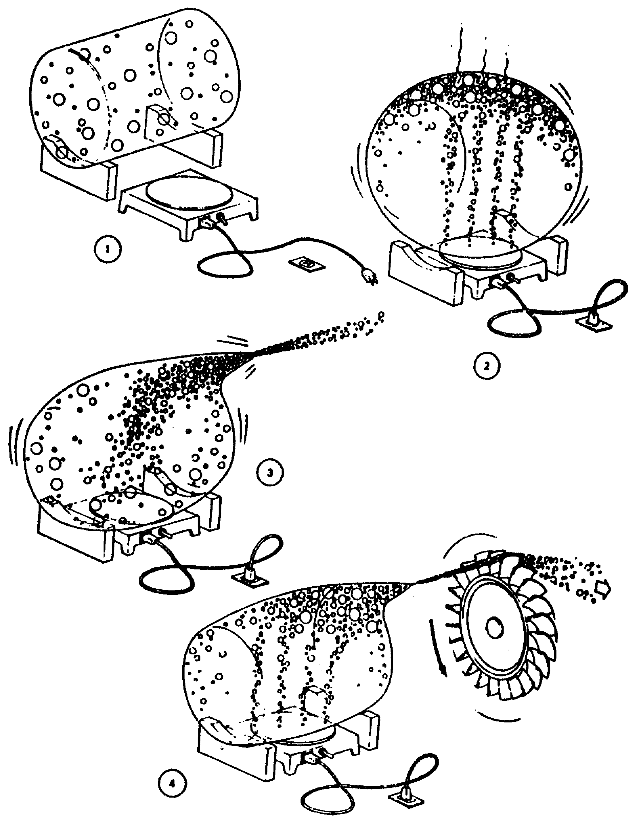

Figure 1-17. Theory of Gas Turbine Engine

26 OD0610

(b) Pressure. A second component required in the acceleration principle is pressure, or driving force. To attain this pressure, container 2 (Figure 1-17) is heated and the molecules contained within expand and exert pressure equally in all directions.

(c) Accelerated Mass. An accelerated mass is obtained by funneling the pressurized gas down a narrow passageway (container 3). It is this convergency or narrowing down of the nozzle area that causes the molecules to accelerate and produce that velocity energy required to perform the rotational mechanical work.

(d) Conversion of Energy. The high velocity gases possess a large amount of kinetic energy. This energy due to motion now must be converted to mechanical energy, which can be accomplished by adding a turbine wheel to container 4 (Figure 1-17). The first force, as seen in the illustration, is the impact or push of the high-velocity gases exiting the nozzle and hitting the turbine wheel. The second force, which is a reaction force, is generated by the high-velocity gases exiting the turbine wheel in the opposite direction of rotation.

27 OD0610

(3) Cycle Characteristics and Variations. The four-stroke/cycle piston-type engine is designed to perform four events: intake, compression, power, and exhaust. One cycle (four events) is completed as the crankshaft rotates twice for a total of 720 degrees. Each event is completed within 180 degrees of crankshaft rotation and is called a stroke. Gas turbine engine operation consists of four events that are essentially the same as the reciprocating engine. Air is first drawn through the air inlet section that relates to the intake event. It then passes through the compressor section, relating to the compression event. The air then enters the combustor, mixes with fuel, and is ignited. As the air-fuel mixture burns, the pressure increase is directed through the turbines that extract work from the flowing gases which relates to the power event. Passing through the turbines, the used gases are exhausted to the atmosphere, relating to the exhaust event. Figure 1-18 illustrates the comparison of events between the four-stroke/cycle piston-type engine and the gas turbine.

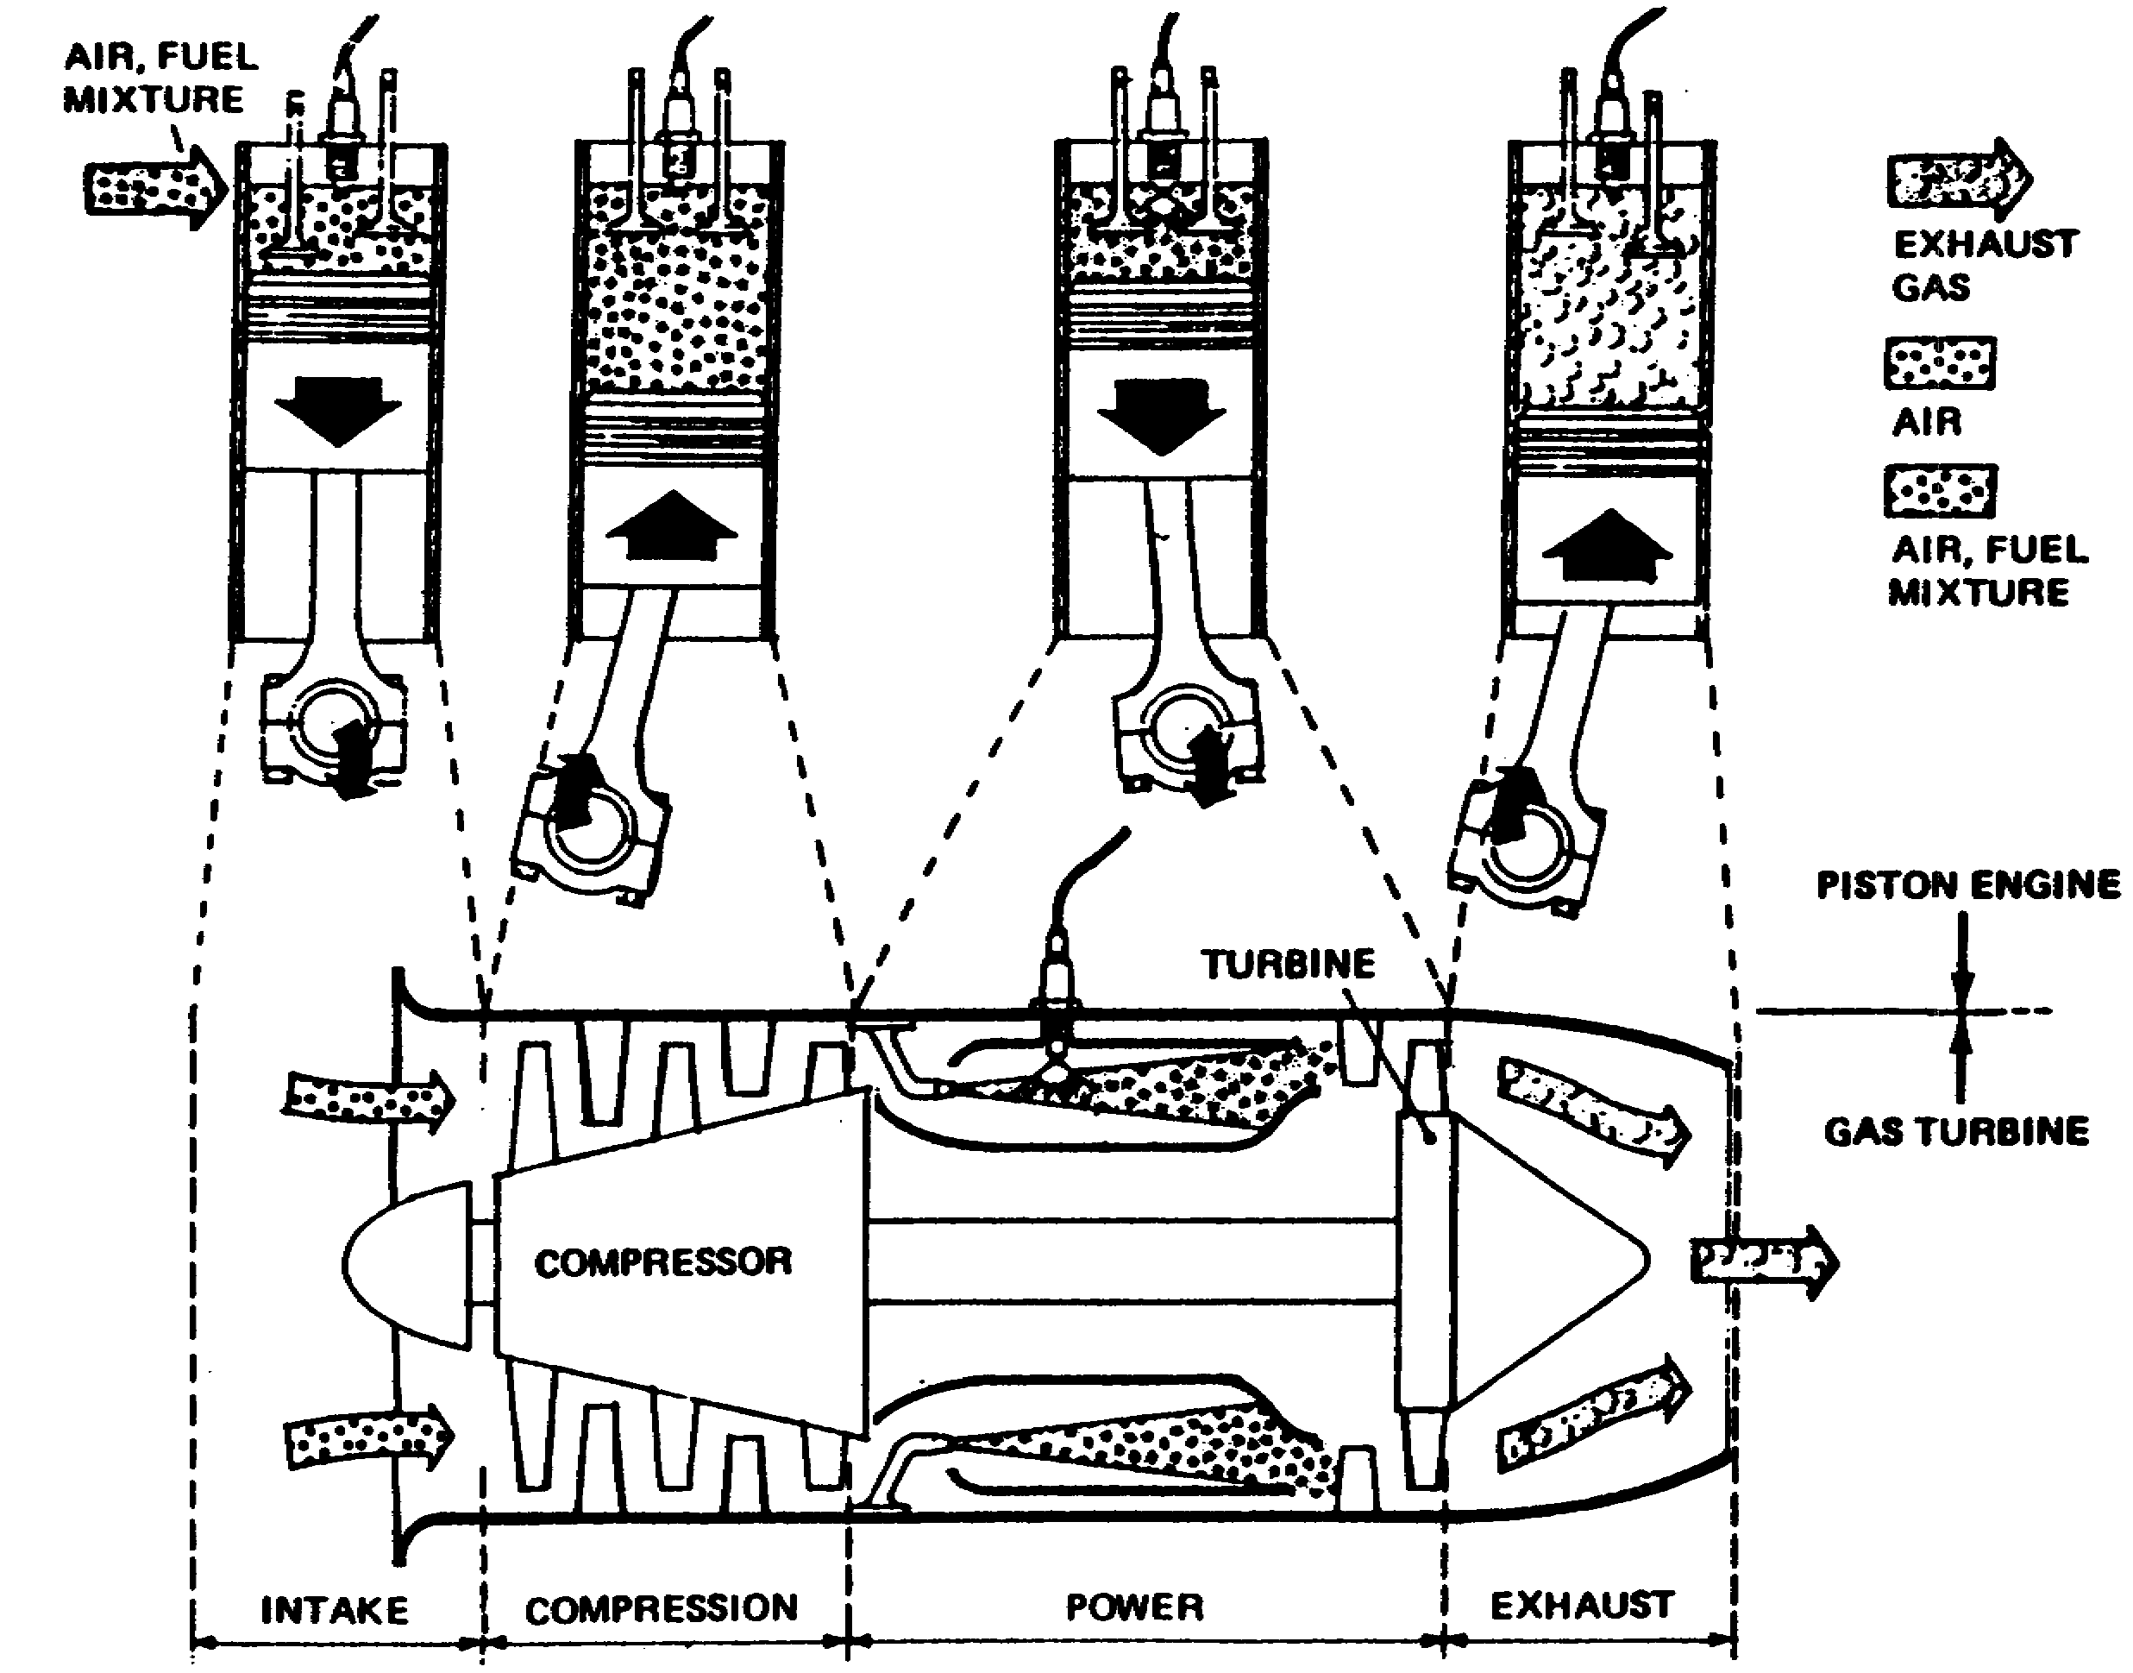

Figure 1-18. Comparison of Piston Engine to Turbine Engine.

28 OD0610

(4) Continuous Combustion. As discussed above, the four-stroke/cycle piston-type engine performs four separate discrete events. Each event must be completed before the next one begins. Basic gas turbine engine operation consists of four events that are essentially the same as the piston-type reciprocating engine; however, these events combine to form a continuous cycle. As the gas turbine operates, each of the four events transpires continuously. In the gas turbine engine, as long as there is a supply of air and fuel to burn, expand, and maintain turbine speed, the cycle is said to be continuous and self-sufficient.

(5) Thermal Comparison. The piston-type engine operates at relatively cooler temperatures than the gas turbine engine. The piston engine withstands combustion chamber temperatures of approximately 5000 degrees Fahrenheit (2760 degrees Celsius) for a short duration of time. The hot components are cooled rapidly to maintain relatively low temperatures of only a few hundred degrees. In the gas turbine, the combustion chamber maintains a constant temperature and limits it to approximately 1000 to 2000 degrees Fahrenheit (537.7 to 1090.3 degrees Celsius). This is done to retain the resilience of internal components and inhibit formation of foreign matter on rotating parts.

(6) Air Inlet Section. The air inlet section (Figure 1-19) serves to furnish a uniform and steady airflow to the face of the compressor. Inlet sections may be equipped with or without inlet guide vanes. Inlet guide vanes serve to direct the air into the first stage of the compressor.

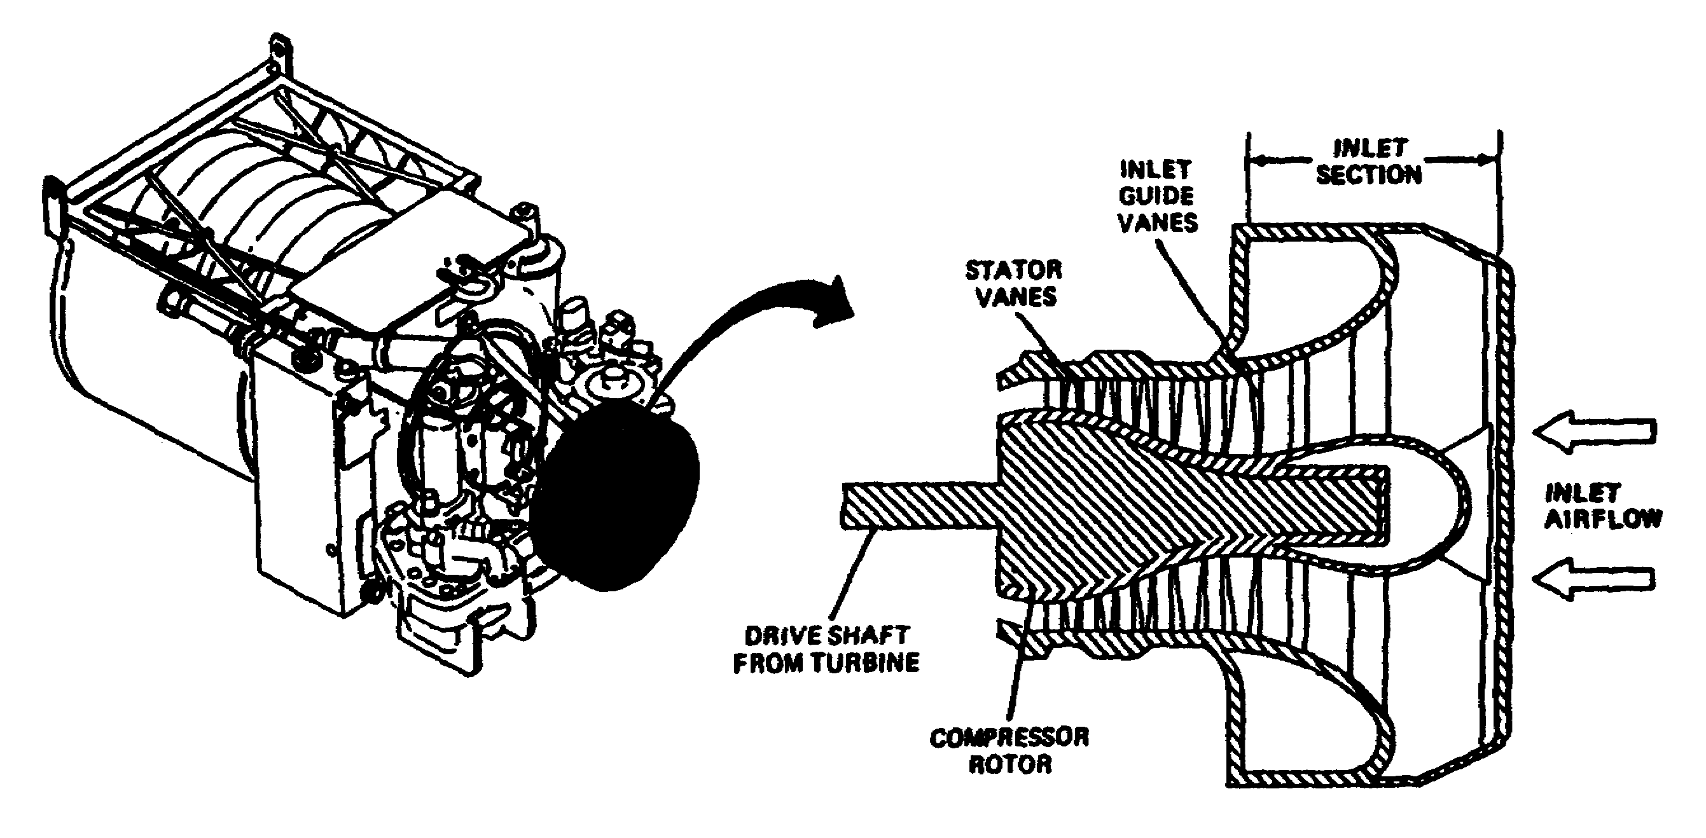

Figure 1-19. Air Inlet Section.

29 OD0610

(7) Compressors. The compressor is designed to provide the combustion chamber with a maximum amount of high-pressure air that is heated and expanded through the turbines. The amount of energy released from the heated airmass is proportional directly to the mass of air consumed. This is the major reason why the compressor is one of the most important components in the gas turbine. A poorly designed compressor will not provide the combustion chamber with the proper amount of high-pressure air, and will result in a lack of power. Modern compressors are able to achieve compression ratios of approximately 15: 1 and efficiencies approaching 90 percent. Two common types of compressors are discussed below.

30 OD0610

(8) Axial. The axial compressor performs the compression process in a straight line parallel to the axis of the engine. The axial compressor is composed of rotating members called rotors and stationary members called stators. A row of rotors and stators is called a stage. The axial compressor is composed of a series of stages (Figure 1-20). During operation, the air is arrested in the first stage of compression and is turned by a set of stator vanes, picked up by a set of rotor blades, and passed through each successive stage to complete the compression process. The rotors increase velocity while the stators decrease the velocity. The successive increases and decreases in velocity practically cancel each other, with a result that the velocity, as the air leaves the compressor, is usually slightly greater than the velocity of the air at the entrance to the compressor. As the pressure is built up by successive sets of rotors and stators, less and less volume is required. Thus, the volume within the compressor is decreased gradually. At the exit of the compressor, a diffuser section within the engine adds the final touch to the compression process by decreasing again the velocity and increasing the static pressure just before the air enters the engine burner section.

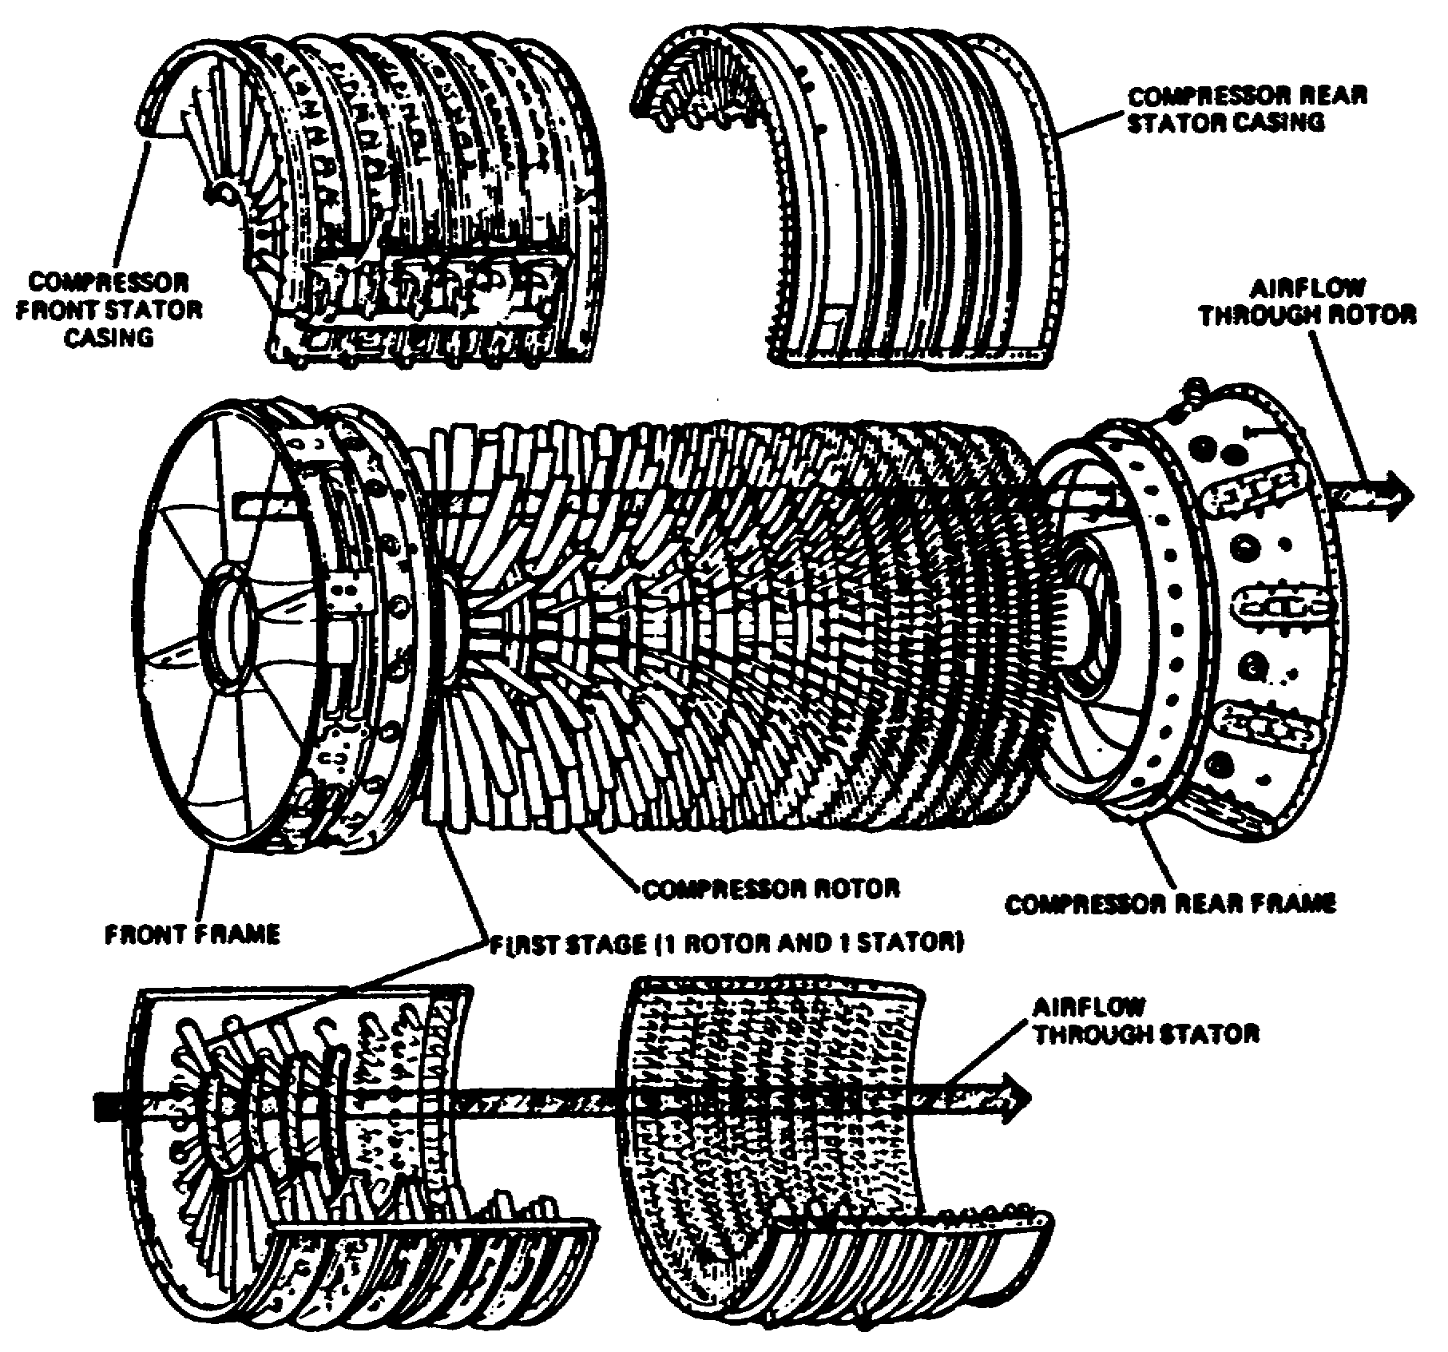

Figure 1-20. Axial Compressor.

31 OD0610

(9) Centrifugal Compressors. This type of compressor consists of two main parts: an impeller and a diffuser. Centrifugal compressors operate by taking in air near the hub of the impeller and accelerating it outward by centrifugal action. The impeller vanes guide the air toward the outer circumference of the compressor, building up the velocity by means of the high rotational speed of the impeller. Air leaves the impeller at high speed and flows through a set of diffuser vanes which decelerates the flow of air, converting high-velocity air to high-pressure energy. The diffuser vanes also serve to straighten airflow. A typical centrifugal compressor is shown in Figure 1-21.

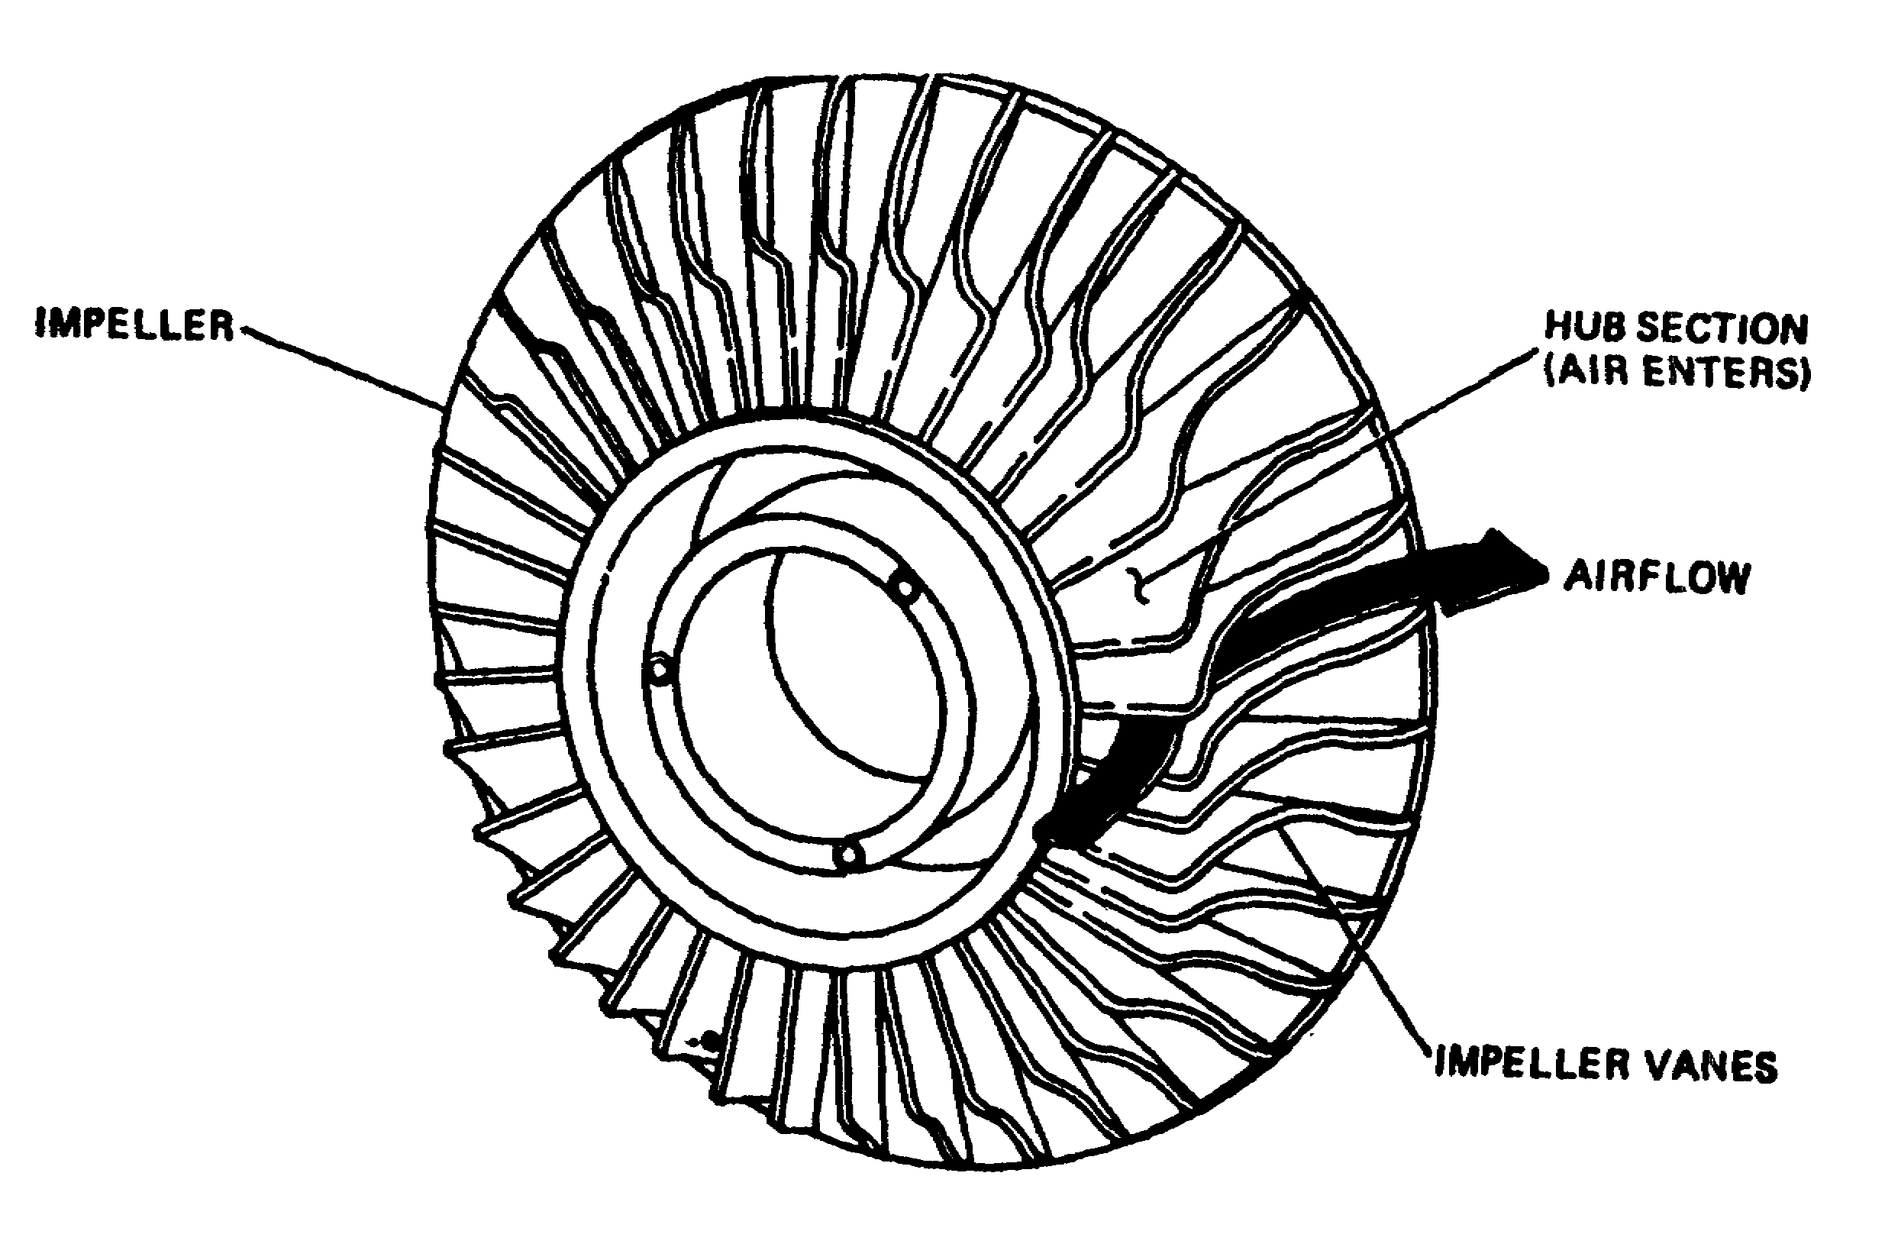

Figure 1-21. Centrifugal Compressor.

32 OD0610

(10) Combustion Chamber. The combustion chamber, Figure 1-22, is designed to burn a mixture of fuel and air, and to deliver the resulting gases to the turbine at a temperature that will not exceed the allowable limits at the turbine inlet. The chamber, within a very limited space, must add sufficient heat energy to the gases passing through the engine. This accelerates their mass enough to produce the desired power for the turbine section. Combustion chambers are built in a number of different designs. The construction is such that less than one-third of the total volume of air entering the chamber is permitted to mix with the fuel. The remaining air is used downstream to cool the combustor surfaces, and to mix with and cool the burned gases before they enter the turbines.

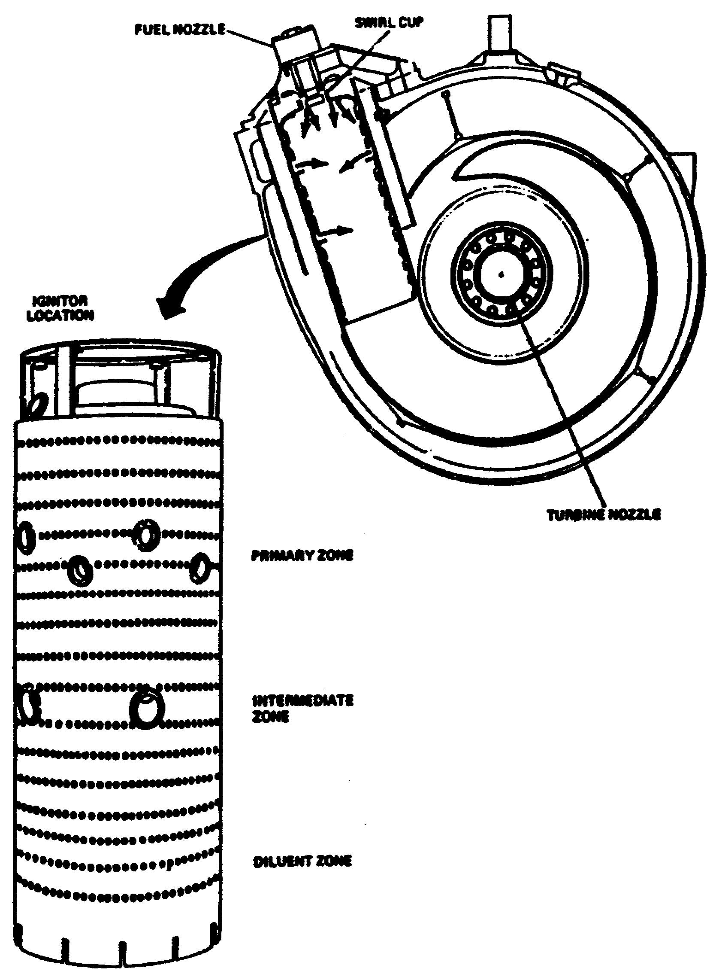

Figure 1-22. Combustion Chamber.

33 OD0610

(11) Recouperator. The function of the recouperator, also called regenerator, is to transfer heat from the exhaust gases to the air entering the engine. This process allows the incoming air to expand prior to combustion. As a result, less heat is required during the combustion process to obtain a fully expanded airmass with maximum velocity. The recouperator is cylindrically shaped with a hollow passageway through the middle. Triangular and oval-shaped ports are placed alternately around the perimeter and pass through the length of the recouperator (Figure 1-23). Two different types of plates are alternately stacked to construct the recouperator.

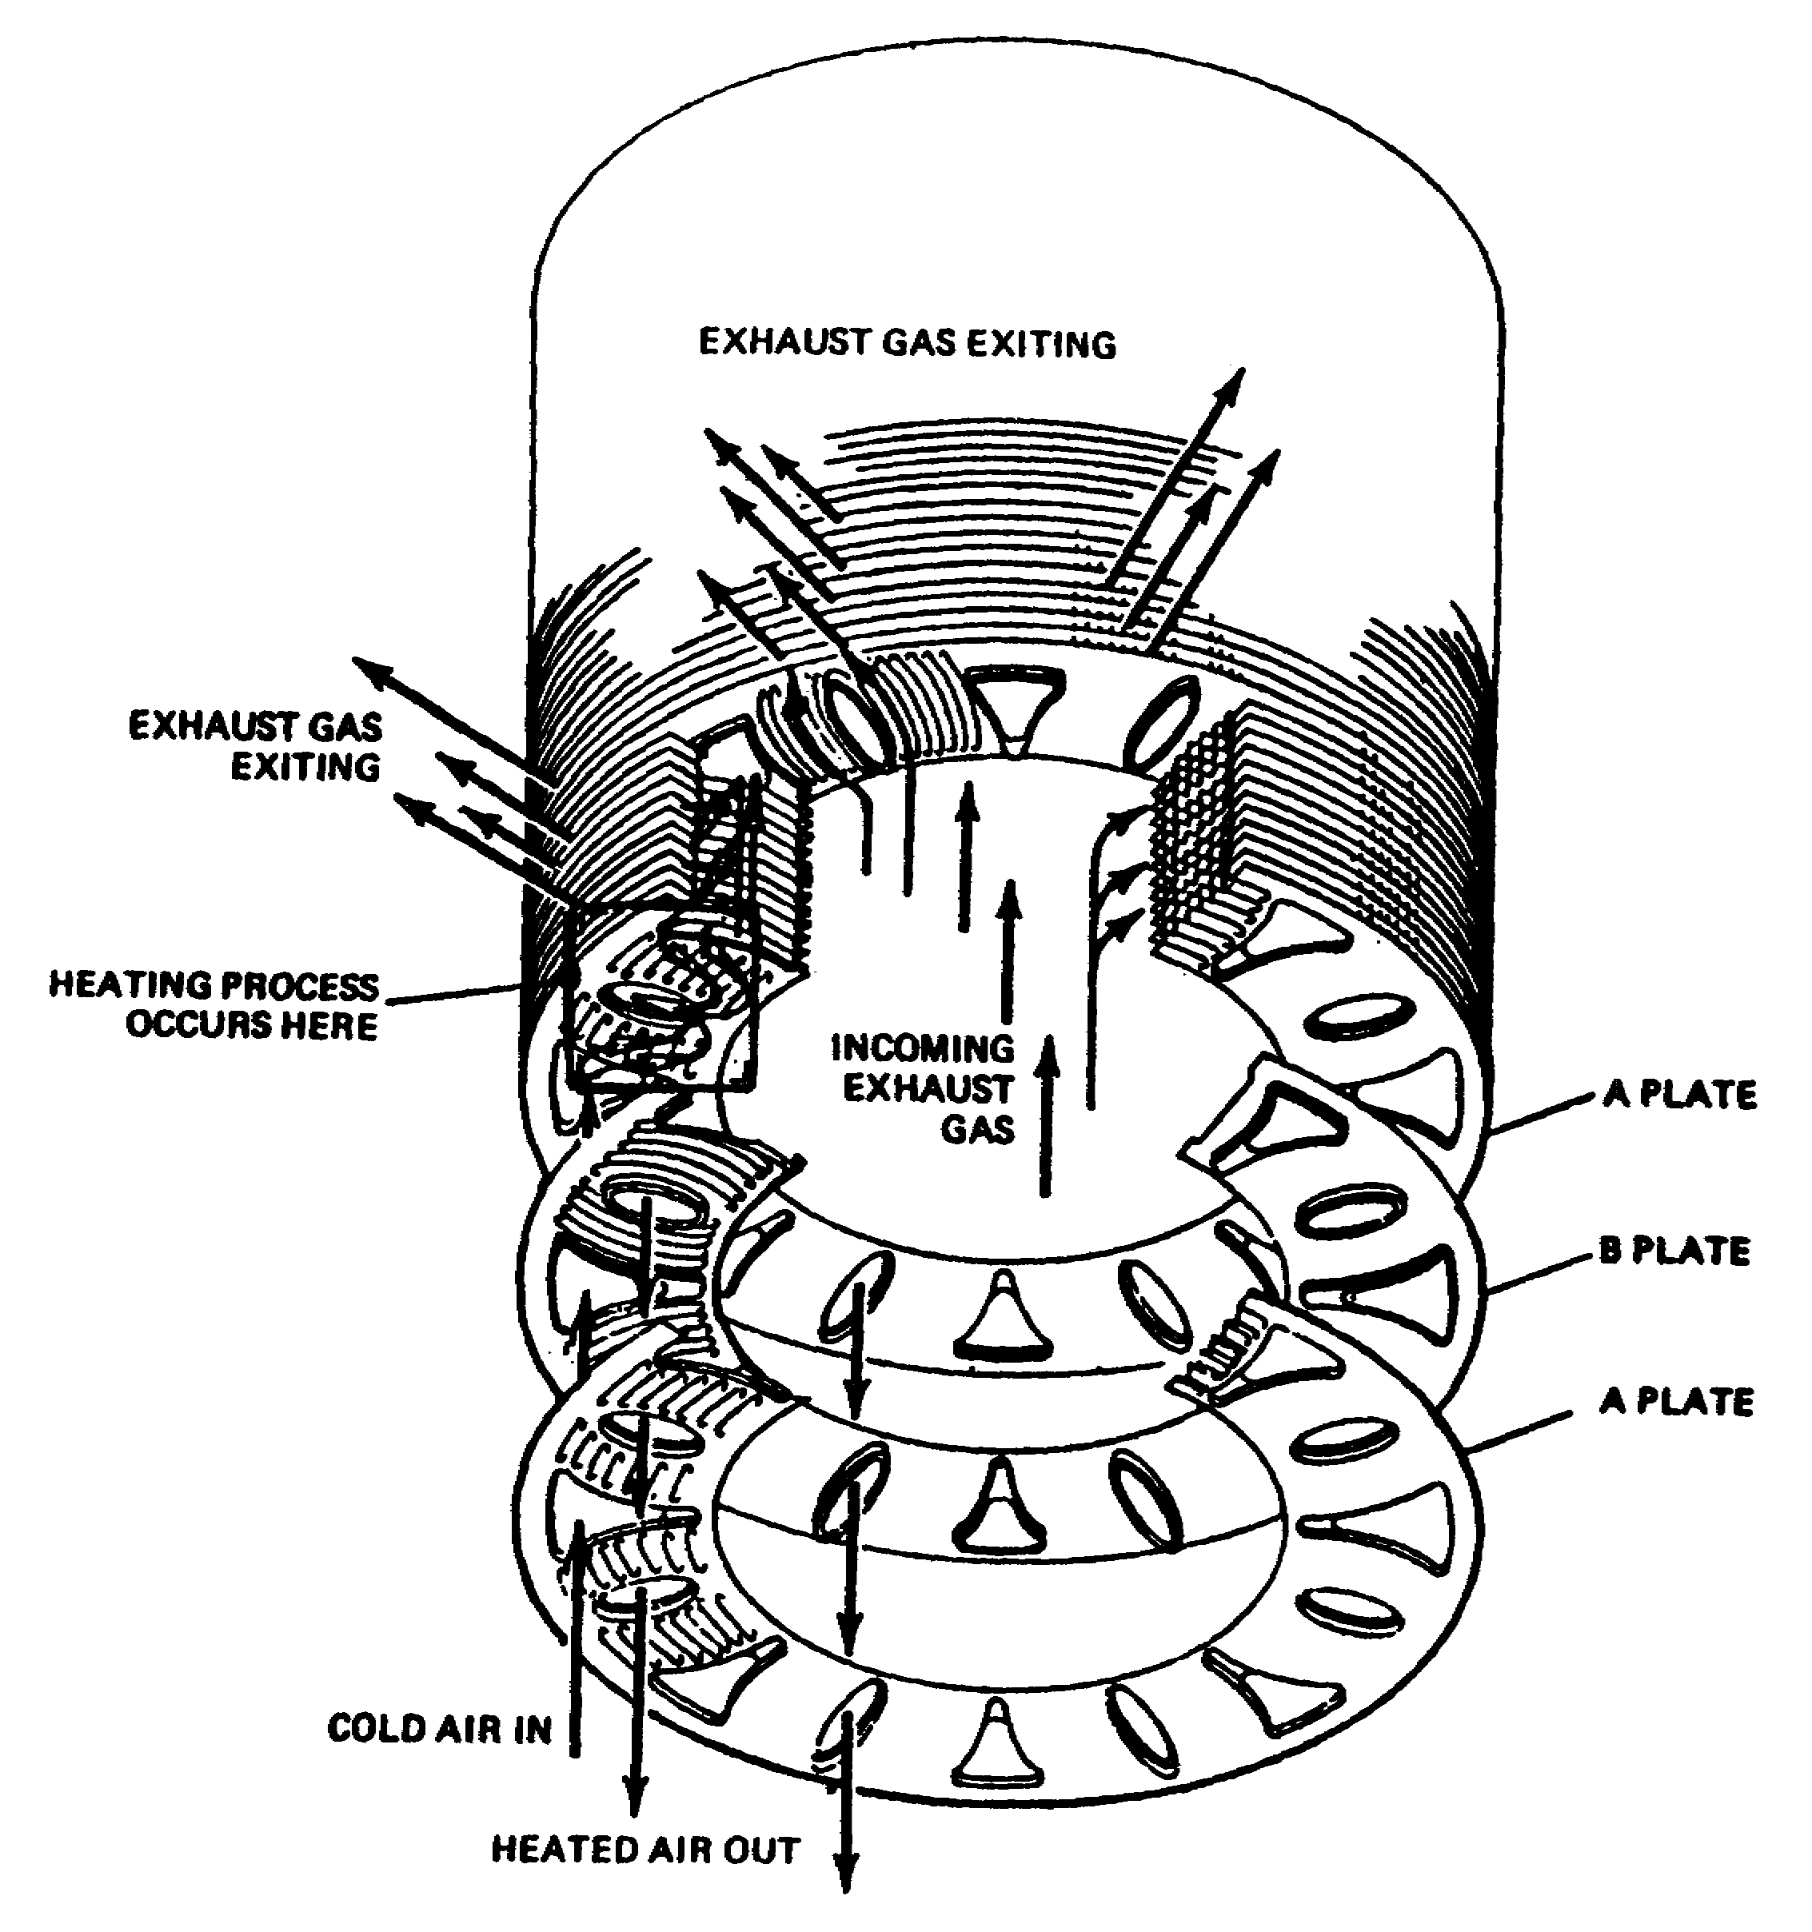

Figure 1-23. Typical Recouperator.

34 OD0610

The air plate (Figure 1-24, A) is constructed with a flat pathway between the oval and triangular ports. The incoming cool air passes down the triangular ports and enters a passage between triangular and oval ports. As the air passes through the pathways, it is heated by exhaust gases exiting above and below the pathway. The exhaust gas enters the middle of the recouperator, passes through heater plates (Figure 1-24, B), and exits the outside of the unit, giving up heat to the cool air in the process. The benefits obtained from the use of a recouperator are listed below.

(a) High thermal efficiency.

(b) Lower specific fuel consumption.

(c) Lower exhaust temperature.

Basically, the only disadvantage to this system is the additional weight of the unit to the vehicle.

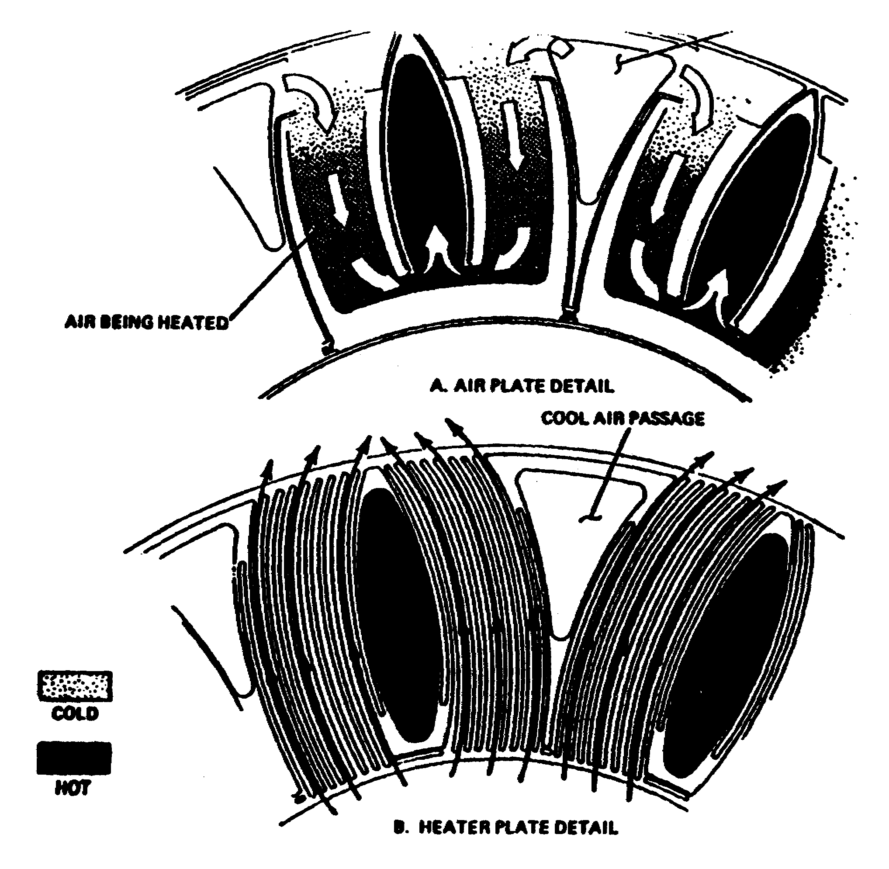

Figure 1-24. Recouperator Plate Detail.

35 OD0610

(12) Turbines. The turbine is designed to extract the kinetic energy (energy due to motion) from the expanding gases that flaw from the combustion chamber. This kinetic energy then is converted into shaft horsepower to drive the compressor and engine accessories. Most of the energy obtained from the products of combustion is used to drive the compressor and the remaining energy is utilized to power additional components such an oiling system and hydraulic systems. Additional power turbines are used to extract residual energy from the moving gases to provide vehicular power. Turbines can be divided into two basic types: radial inflow and axial flow.

(a) Radial Inflow. This type of turbine (Figure 1-25) is similar to the centrifugal compressor in design and construction. Radial inflow operates as the inlet gases pass through openings that direct the gases onto the blades at the base of the compressor. The gas then acts against the blades of the turbine to produce the rotational effect. The gases then are exhausted at the top of the turbine, parallel to the axis of rotation. Despite its simplistic design and durability, the radial inflow turbine generally is limited to use in smaller engines.

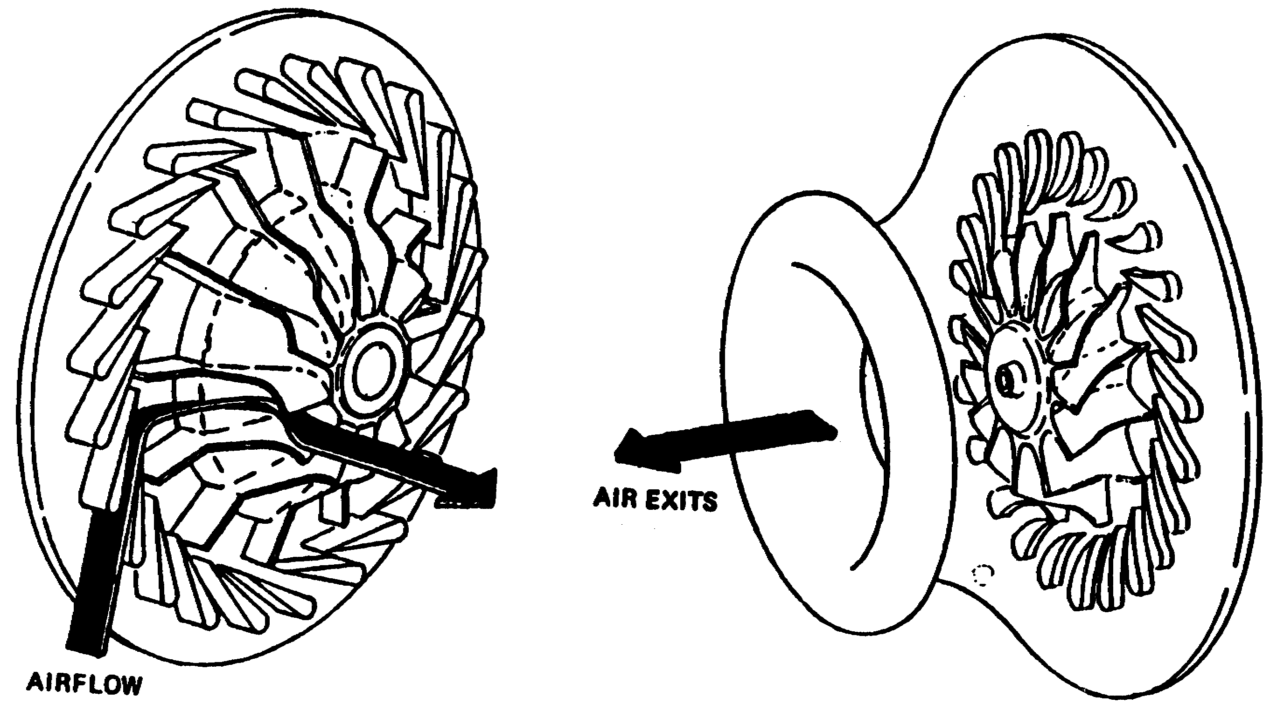

Figure 1-25. Radial Inflow Turbine.

36 OD0610

(b) Axial Flow. The axial flow turbine (Figure 1-26) is composed of two main elements: a set of stationary vanes and a turbine rotor or rotors. The axial flow turbine rotors are categorized into two basic types: impulse and reaction. The modern turbine consists of a combination of these two called the impulse-reaction turbine. Each is discussed below. As the name implies, the axial flow turbine wheel extracts kinetic energy from the moving gases that flow in a relatively straight line, parallel to the axis of rotation. The turbine wheel is used as the rotating element. Stationary vanes are used to deliver the gas to the next stage in the most efficient way possible.

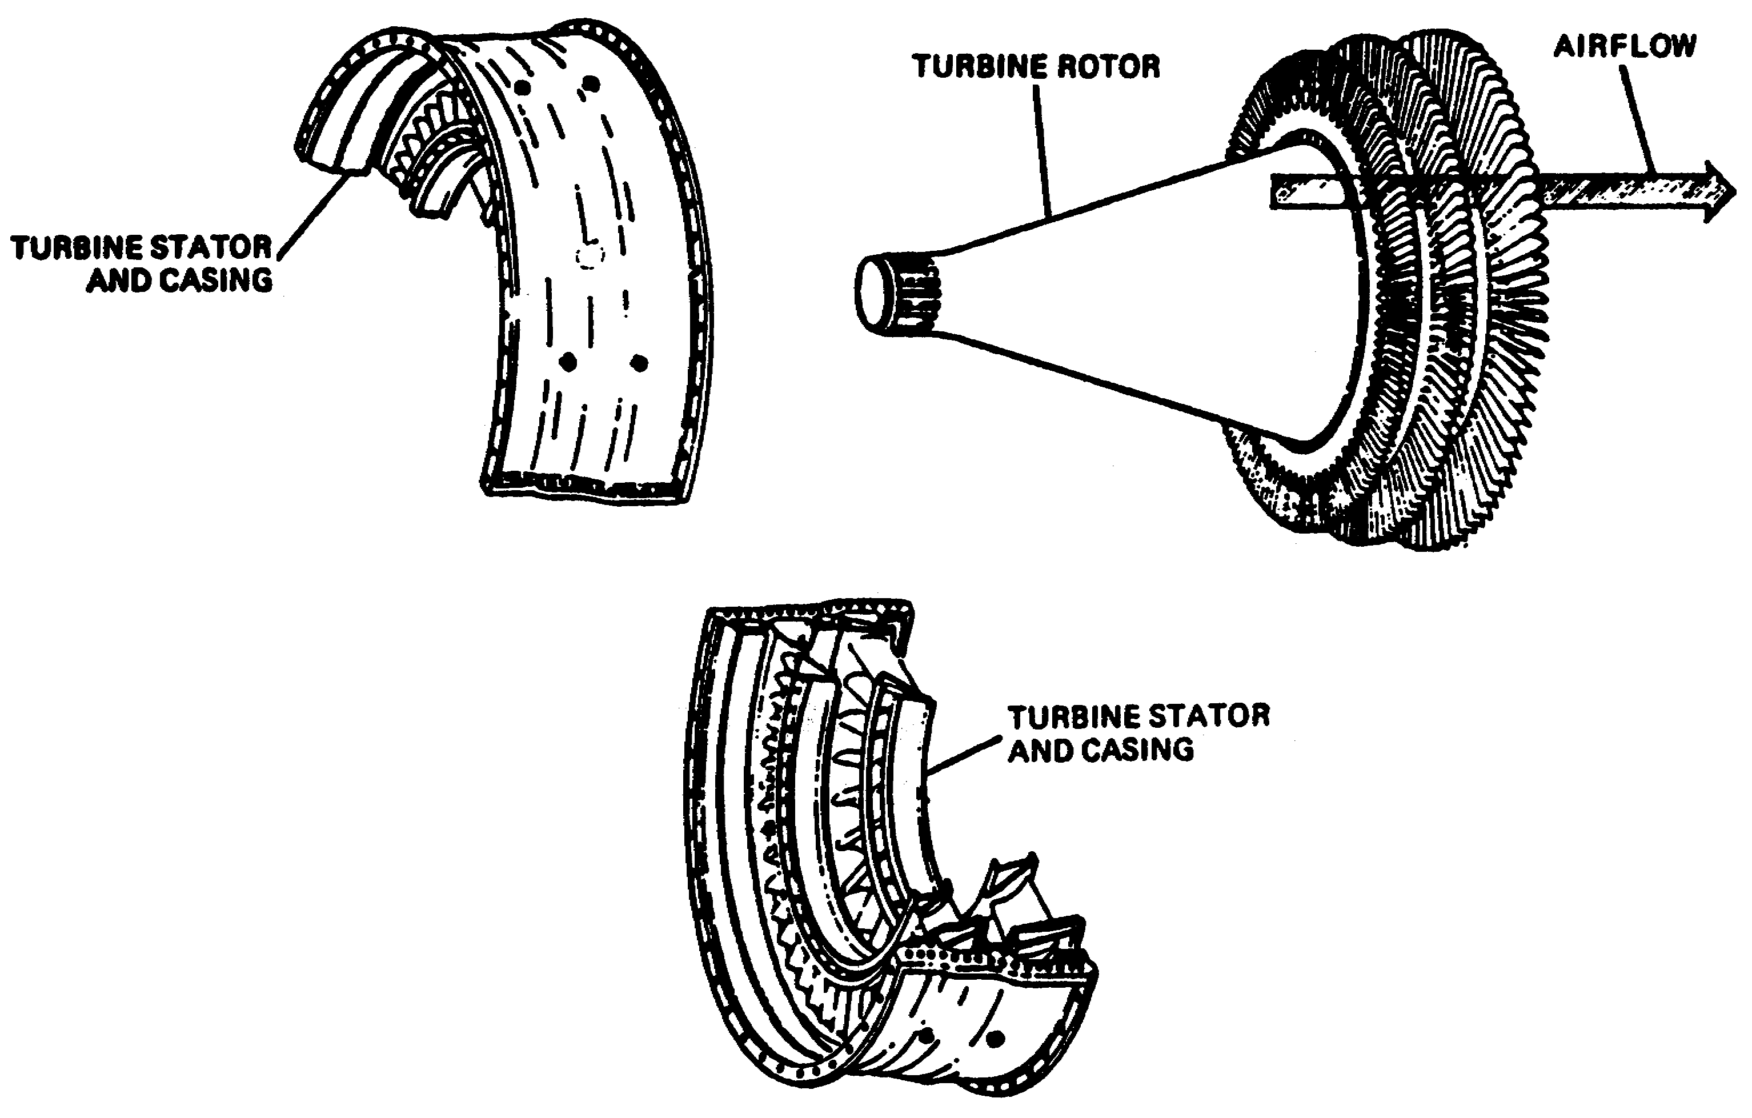

Figure 1-26. Axial Flow Design.

37 OD0610

o Impulse Turbine. The construction of the impulse turbine is illustrated in Figure 1-27. In this configuration, the area of the inlet and exit of the turbine blades are made equal. Thus, the velocity of the gas entering the blade is equal to the exiting velocity (minus frictional losses). The blades are designed in such a way that the high-velocity gases concentrate their energies on the center of the blade. The gases then bounce off the blade at an angle respective to the approach angle producing the force required to turn the blade.

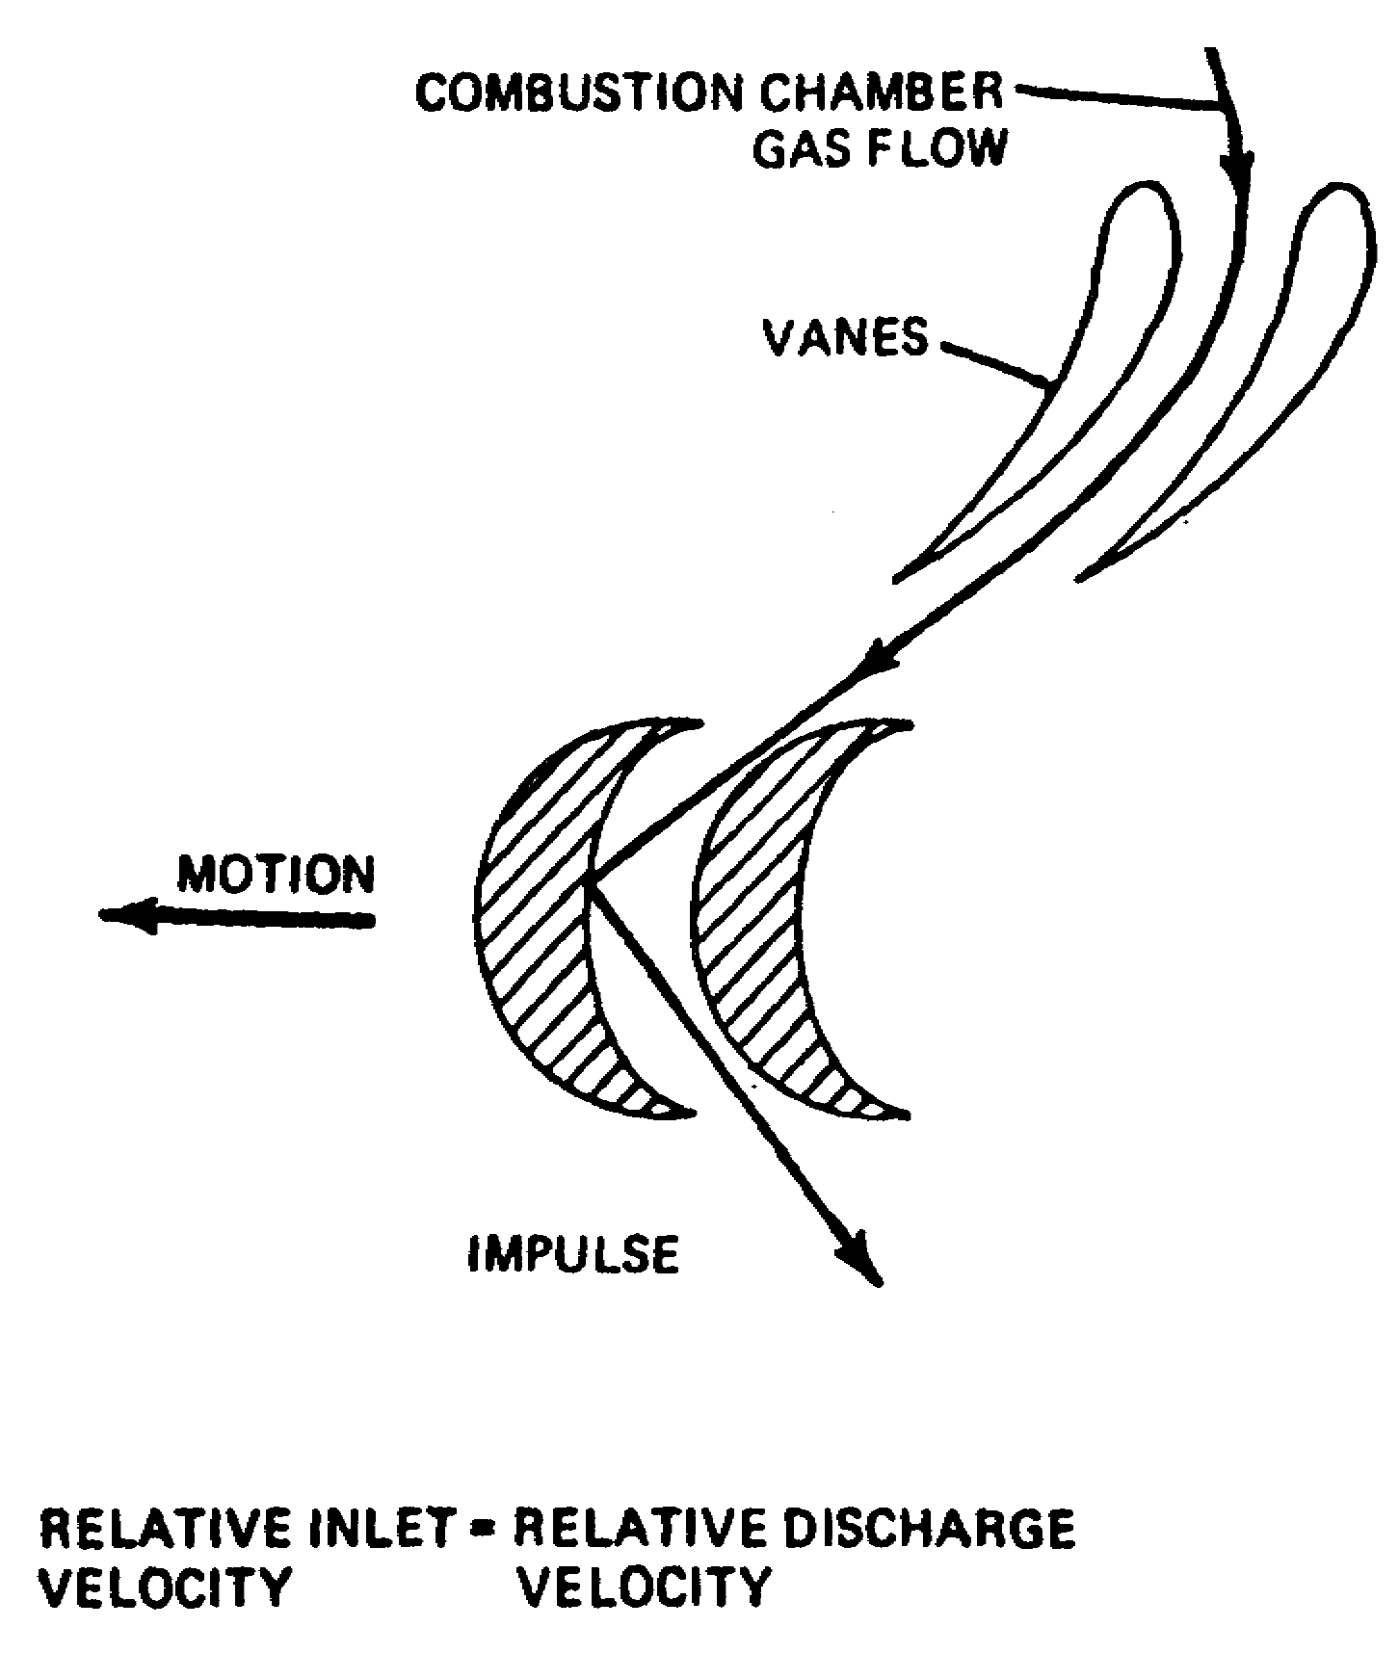

Figure 1-27. Impulse Turbine.

38 OD0610

o Reaction. The reaction turbine operates on the differential pressure principle much like the wing of an airplane (Figure 1-28). As the gases enter a converging passageway on the first-stage rotor, an increase in velocity and a decrease in pressure is experienced. The result is a rotation of the turbine wheel in the direction of low pressure. The reaction turbine wheel, therefore, does not require relatively high entrance velocities as does the impulse turbine.

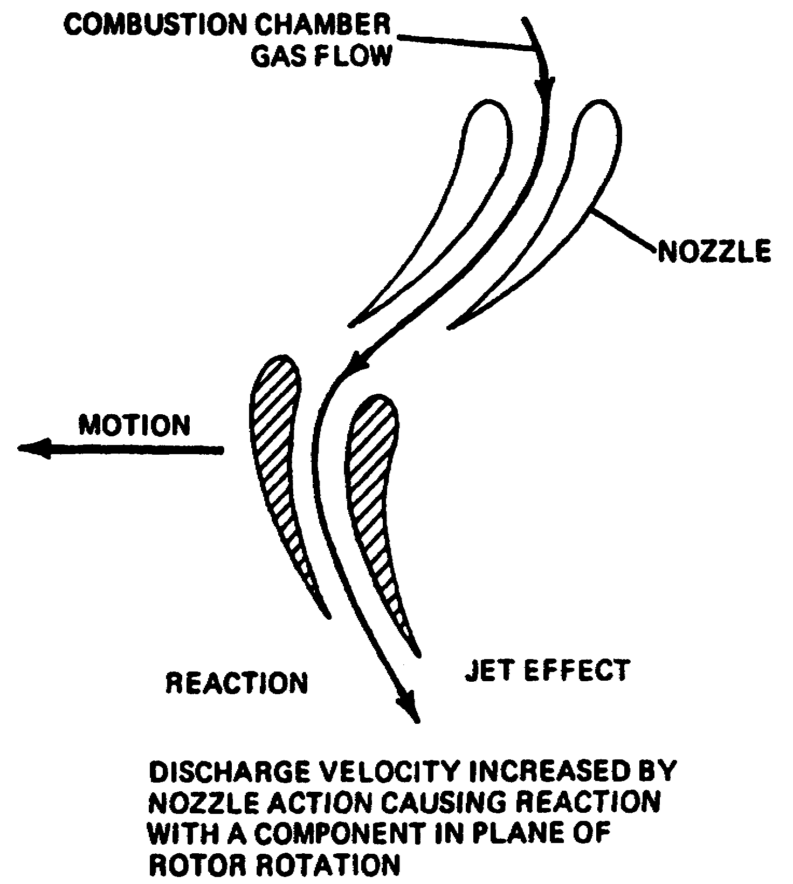

Figure 1-28. Reaction Turbine.

o Impulse-Reaction. The impulse-reaction turbine blade is a combination of both the impulse and reaction designs. The larger circumference of the assembly at the ends of the turbine blades requires the tips to travel at a faster rate of speed than the roots to obtain the same degree of rotation. The impulse-reaction type blade uses this concept to equalize the velocities of the gases exiting the root and tip of the turbine wheel. This type is designed so that the base of the blade is an impulse design and the tip is a reaction design. This provides an equal pressure distribution across the blade and therefore, an efficient turbine blade. The impulse-reaction turbine blade is used almost exclusively in modern turboshaft engines.

39 OD0610

c. Construction. Turbines operate at speeds ranging from approximately 8000 to 60,000 rpm, depending on engine size. These high rotational speeds induce high-stress factors, which must be overcome for safe and efficient operation. The turbine is constructed of a disk and blades, each of which is carefully balanced and weighed. The blades (sometimes called buckets) are attached to the disk by a fir tree design. This design provides for different rates of expansion between blade and disk. The blades are attached axially by fasteners or rivets. Turbine blades can be open at the ends or constructed to form a shroud. Turbine temperature must be monitored closely during operation. To exceed the maximum operating temperature could result in changing the temper of the blades. This condition can change the pitch of the blades and render the engine less efficient and dangerous to operate.

d. Exhaust. The exhaust gases pass radially outward through the recouperator core into a collection plenum that is connected to the vehicle exhaust duct.

40 OD0610

LESSON, PART B

Practice Exercise

The following items will test your grasp of the material covered in this lesson. There is only one correct answer for each item. When you have completed the exercise, check your answers with the answer key that follows. If you answer any portion incorrectly, study again that part of the lesson which contains the portion involved.

1. What is the main difference between gasoline and diesel engines?

2. What controls the speed and power output of diesel engines?

3. Why is the cycle of a diesel engine referred to as having constant pressure?

4. What is the name of the two (2) compressors in the turbine engine that air flows through before entering the engine?

41 OD0610

5. What are the three (3) benefits obtained from the use of a recouperator?

6. What are the four (4) basic principles that mast be understood, in order to master the theory of operation behind the gas turbine engine?

43 OD0610

LESSON, PART B

PRACTICE EXERCISE

ANSWER KEY AND FEEDBACK

Item Correct Answer and Feedback

1. The main difference between gasoline and diesel engines is in the method of introducing the fuel into the cylinders and igniting the air-fuel mixture. Page 19, para a. (1).

2. The speed and power output of diesel engines are controlled by the quantity of fuel injected into the cylinders. Page 22, para (3).

3. Continuous combustion (burnout) throughout the entire power stroke is referred to as a constant pressure. Page 22, para (4).

4. Compressors the air flows through are low compressor and high compressor. Page 24, para 1. (a).

5. Benefits obtained from the use of a recouperator are high thermal efficiency, lower specific fuel consumption, and lower exhaust temperature. Page 35, paras (a), (b), and (c).

6. The four basic principles are mass, pressure, accelerated mass, and conversion of energy. Page 25, para (2).

44 OD0610

